 

**Informatics Institute of Technology**

**Department of Computing (BSc.) in Computer Science**

**Module: 5DATA001C.2**

**Machine Learning and Data Mining**

**Module Leader: Mr. Achala Aponso**

Date of Submission : 09/052022

Name : K.A.D.S.T.Kumarapeli

UOW No : W1790958

IIT No : 2019952

Contents

Clustering Part 3

EDA- Get High Level Idea about dataset 4

Outlier Removal and Feature Scaling - Preprocessing 6

Define the number of cluster centers 13

K-means Clustering 19

Dimensionality Reduction (PCA) 37

Time Series Forecasting 46

Construct time-delayed values 48

Data Normalization 56

One-hidden Layer Neural Network Architecture 61

Two-hidden Layer Neural Network Architecture 67

Experimenting with Learning rate 73

Prediction with best MLP architecture 75

Appendix 80

Clustering 80

Forecasting 84

References 92

# Clustering Part

With the given problem description, we will be able to perform all tasks whit in below steps.

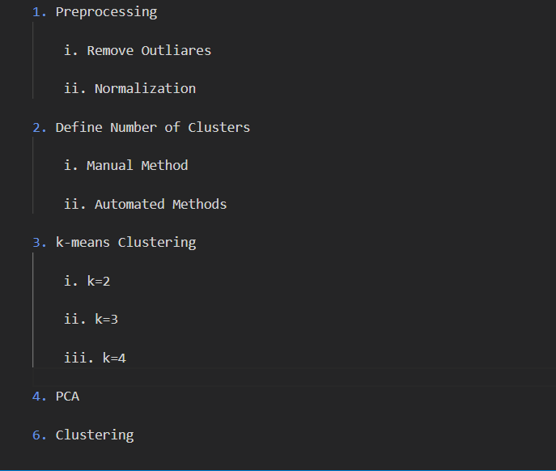

## EDA- Get High Level Idea about dataset

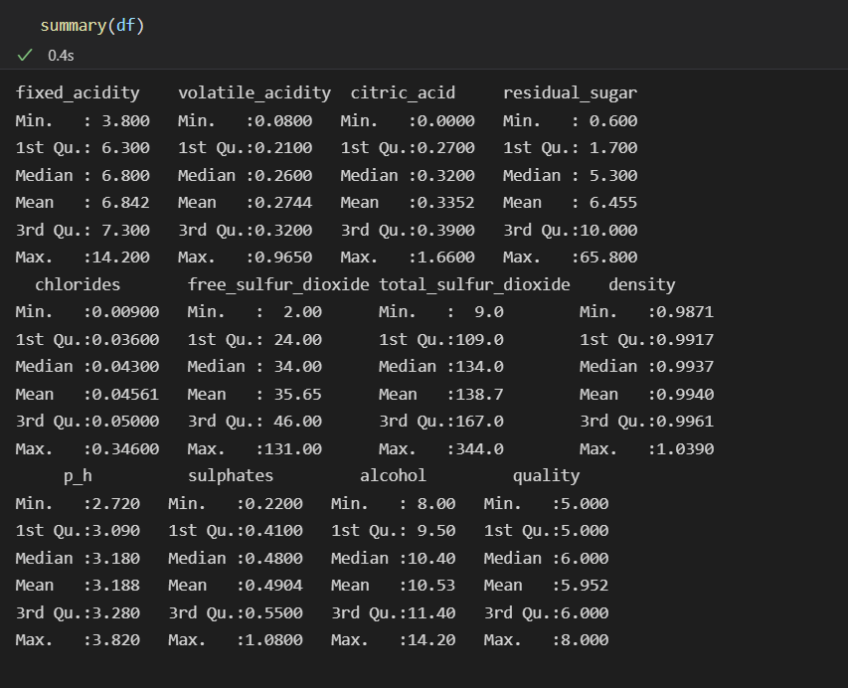

From above figure we will be able to get an idea about the dataset and the data distribution with Min and Max Values and Some Statistical Measures of the Dataset.

There are 4710 total observations and 12 features in this dataset. There is a column called quality which is ordinal variable to represent quality of each red wine sample and it has four qualities such as 5,6,7,8 and in this project, I will map these values to 1,2,3,4 and it will be help in next stages.

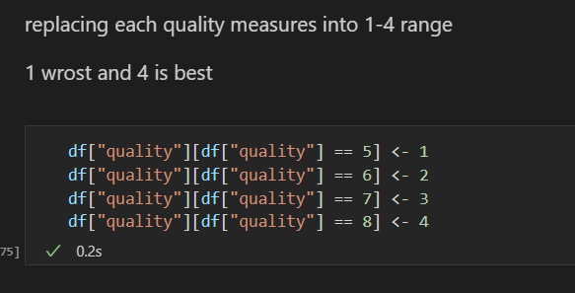

Missing Values!

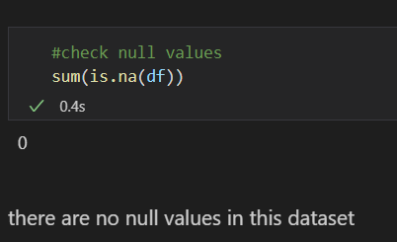

There are not any missing values that we have to deal with in this dataset.

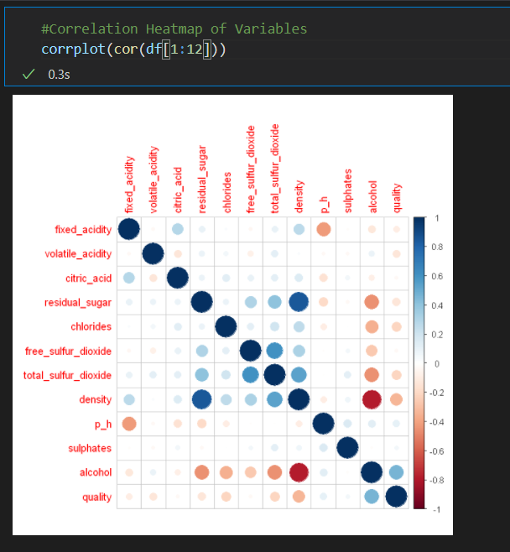

By using this figure, we can see alcohol level is the most correlated feature for the Quality.

## Outlier Removal and Feature Scaling - Preprocessing

**Outlier Removal**

Outlier is a silent killer, an observation that is numerically distant from the rest of the data or in a simple word it is the value which is out of the range.

Reasons for outliers,

* Data Entry Errors: - Human errors such as errors caused during data collection, recording, or entry can cause outliers in data.

* Data Entry Errors: - Human errors such as errors caused during data collection, recording, or entry can cause outliers in data.

* Measurement Error: - It is the most common source of outliers. This is caused when the measurement instrument used turns out to be faulty.

* Natural Outlier: - When an outlier is not artificial (due to error), it is a natural outlier. Most of real-world data belong to this category.

For detect outliers we can use different techniques such as Hypothesis Testing, Z-score methos, Isolation Forest and Visualizing the Data. In this Project We use Z-score Method.

**IQR method**

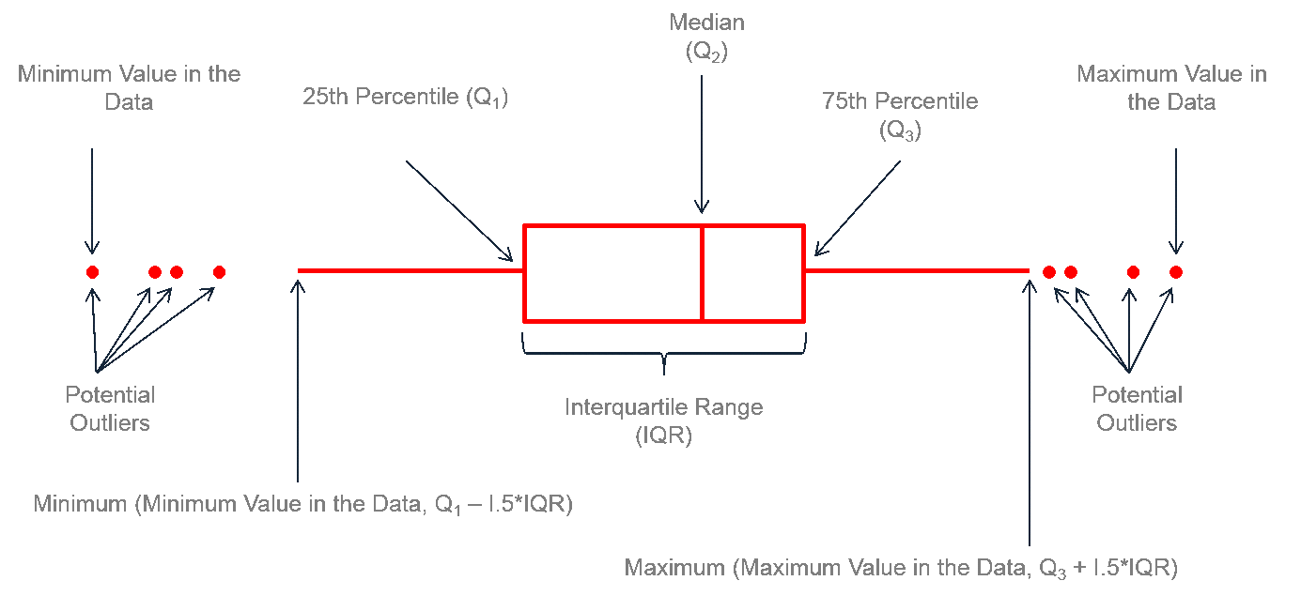

Figure 1 : IQR method

Any Value which is -1.5*IQR > x or 1.5*IQR > x treated as outliers.

* Q1 represents the 1st quartile/25th percentile of the data.

* Q2 represents the 2nd quartile/median/50th percentile of the data.

* Q3 represents the 3rd quartile/75th percentile of the data.

* (Q1–1.5*IQR) represent the smallest value in the data set and (Q3+1.5*IQR) represent the largest value in the data set.

**Z-Score Method**

Using this method, we will be able to find how many Slandered Deviations value away from the mean.

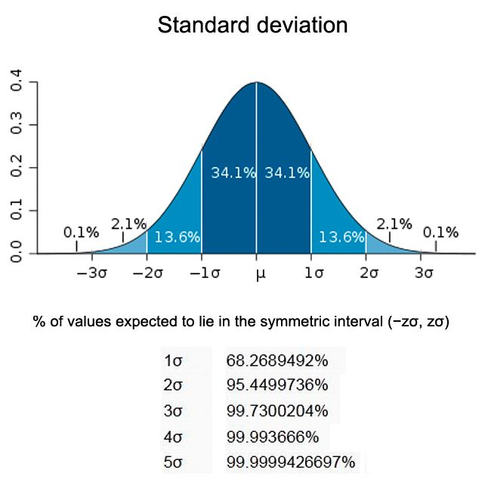

Figure shows area under normal curve and how much area that standard deviation covers.

* 68% of the data points lie between + or - 1 standard deviation.

* 95% of the data points lie between + or - 2 standard deviation

* 99.7% of the data points lie between + or - 3 standard deviation

By experimenting above mentioned IQR method I experienced most of the data points are eliminated with IQR method. Because of that reason we are using Z-score method to Scale and Remove Outliers in this Dataset.

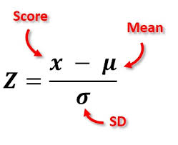

Figure : z-score formula

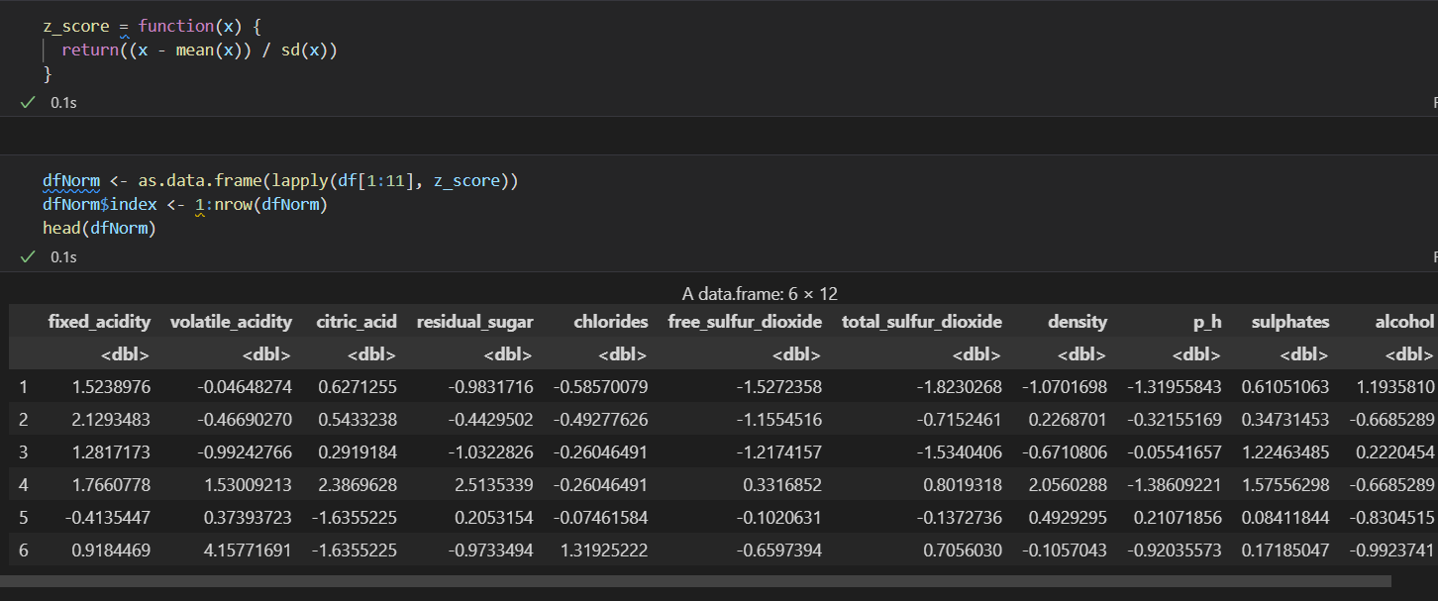

Figure : applying z-score normalization

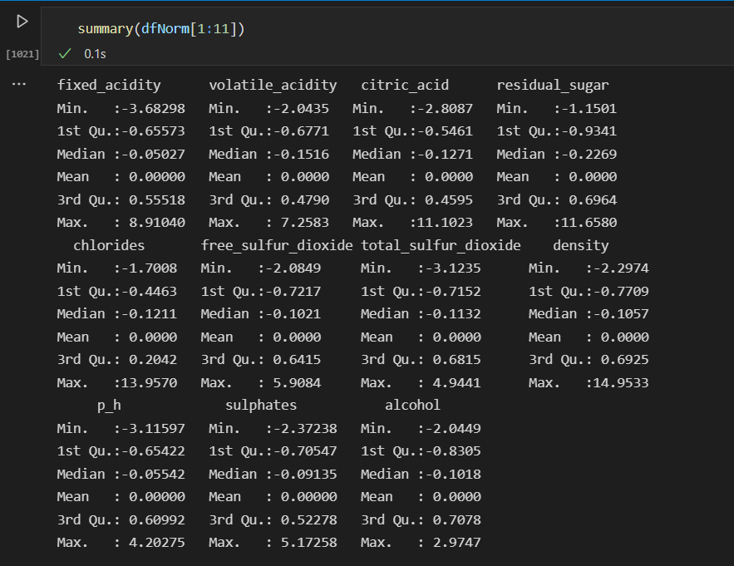

Figure : summary of normalized data frame

Eliminating all outliers using z-score,

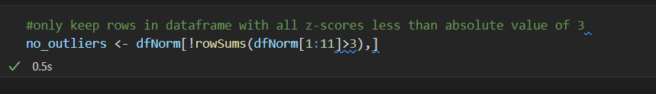

Figure : eliminating outliers

Below figure shows a summary of final dataset after scaling and outlier removal.

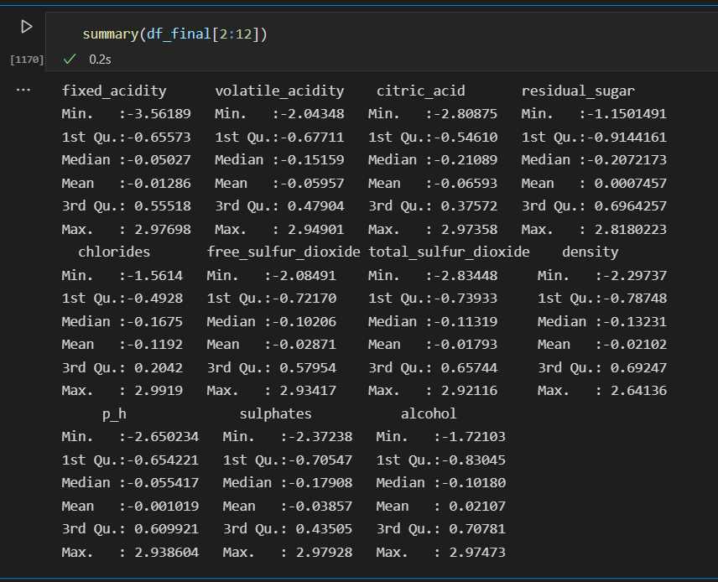

Figure : summary of scaled and outlier removed data frame

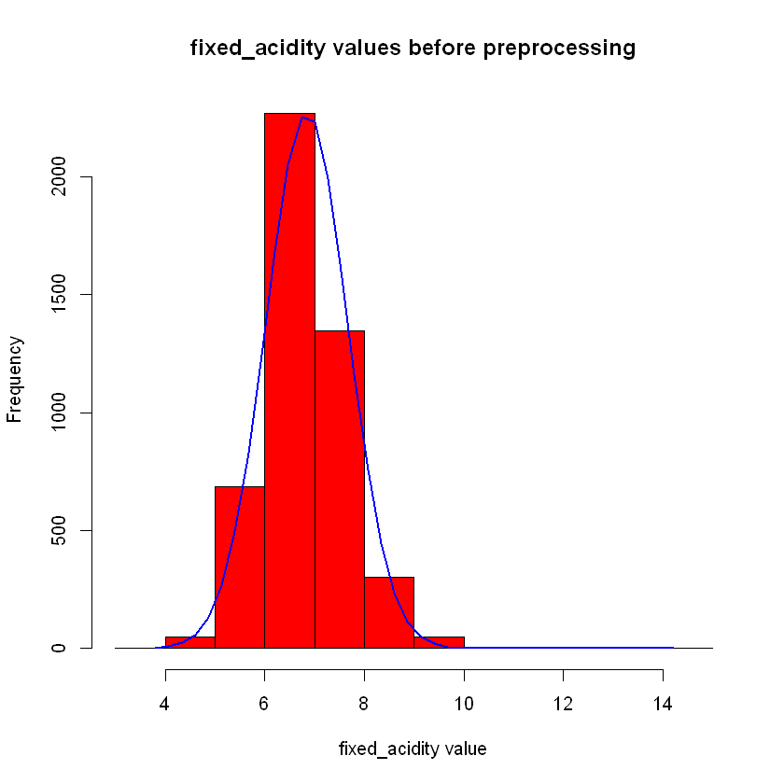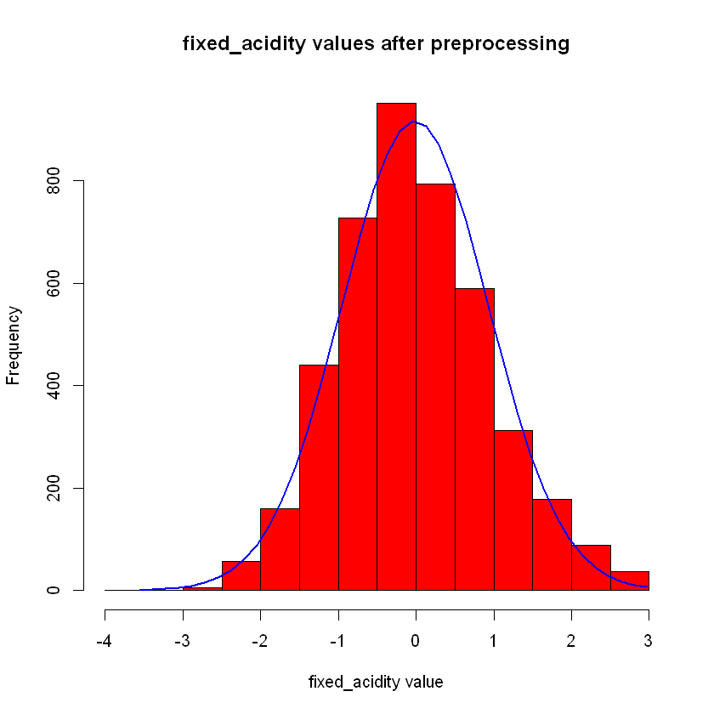

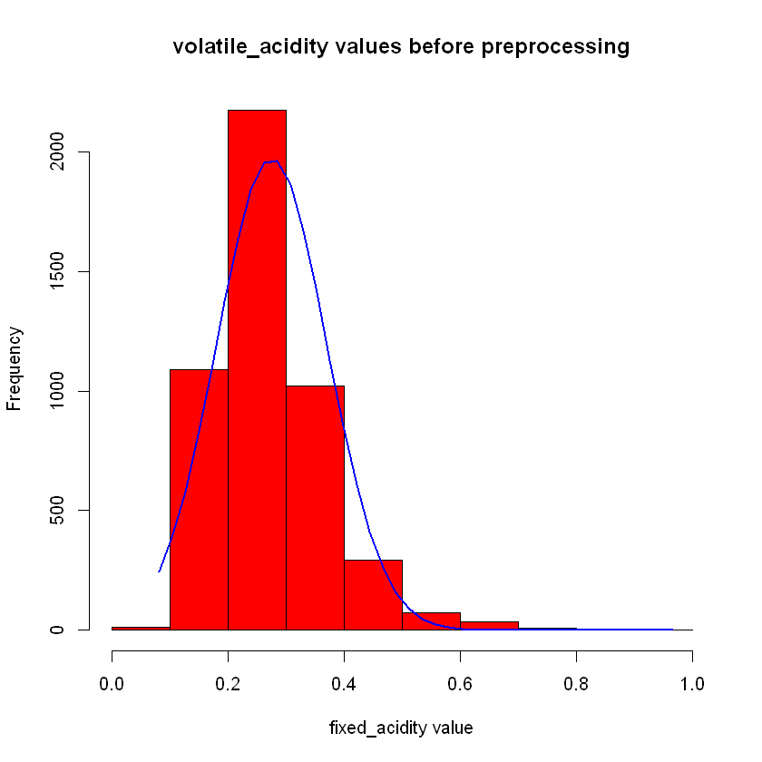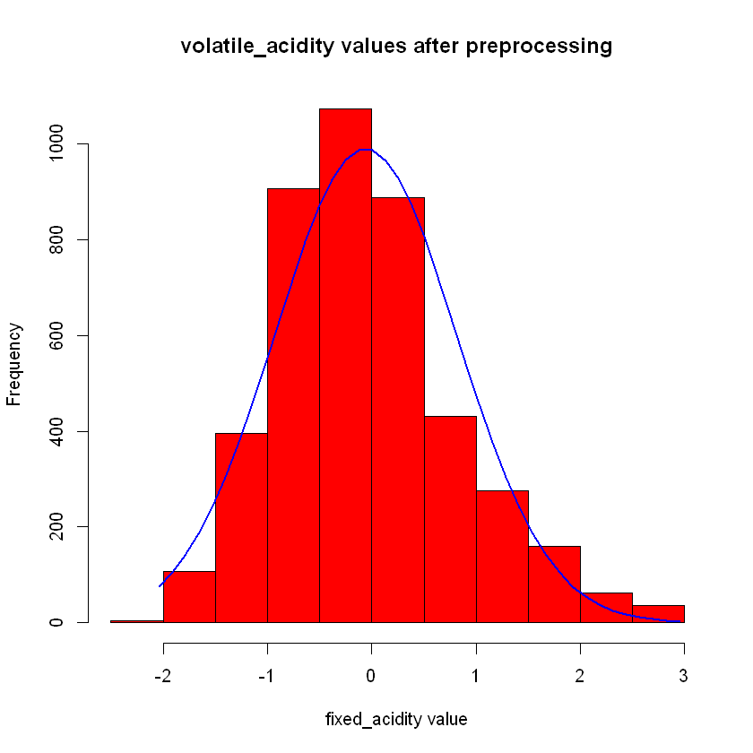

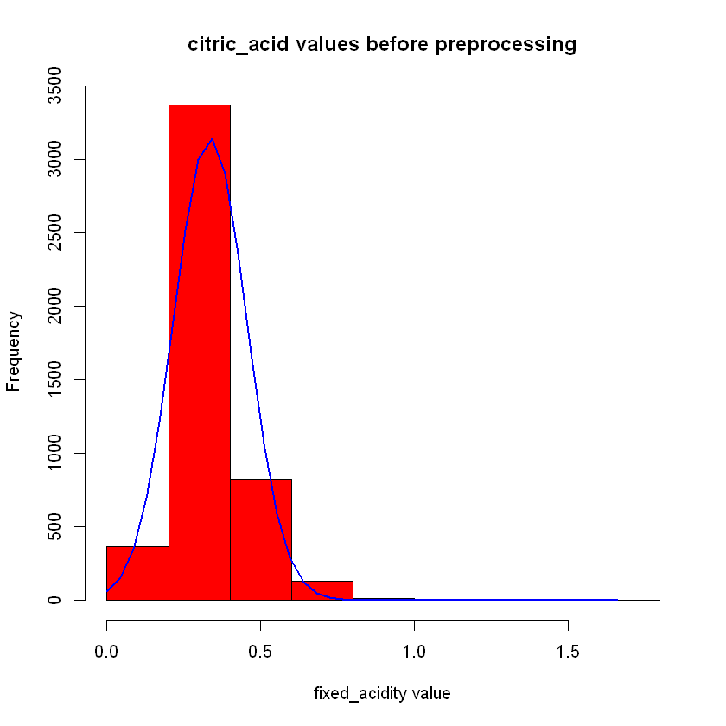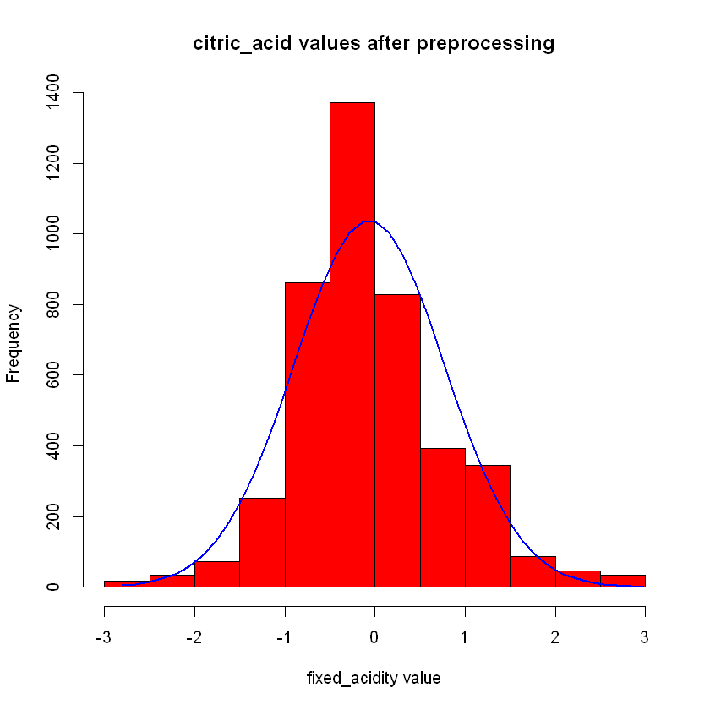

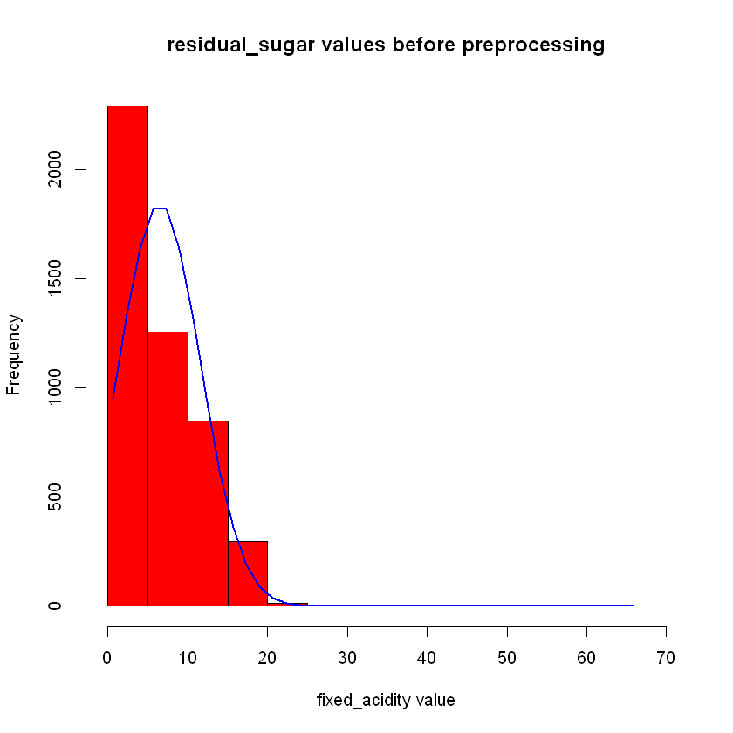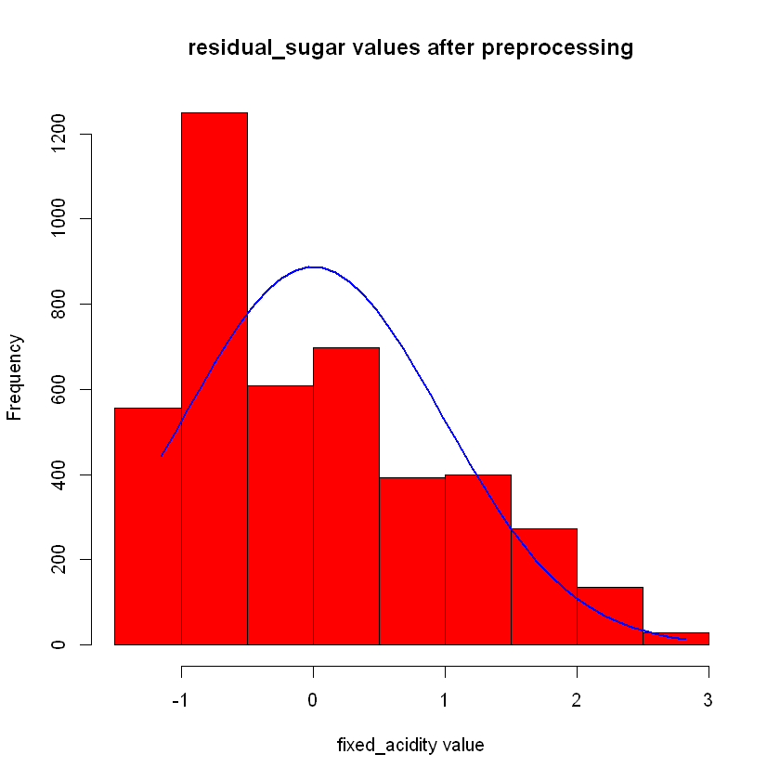

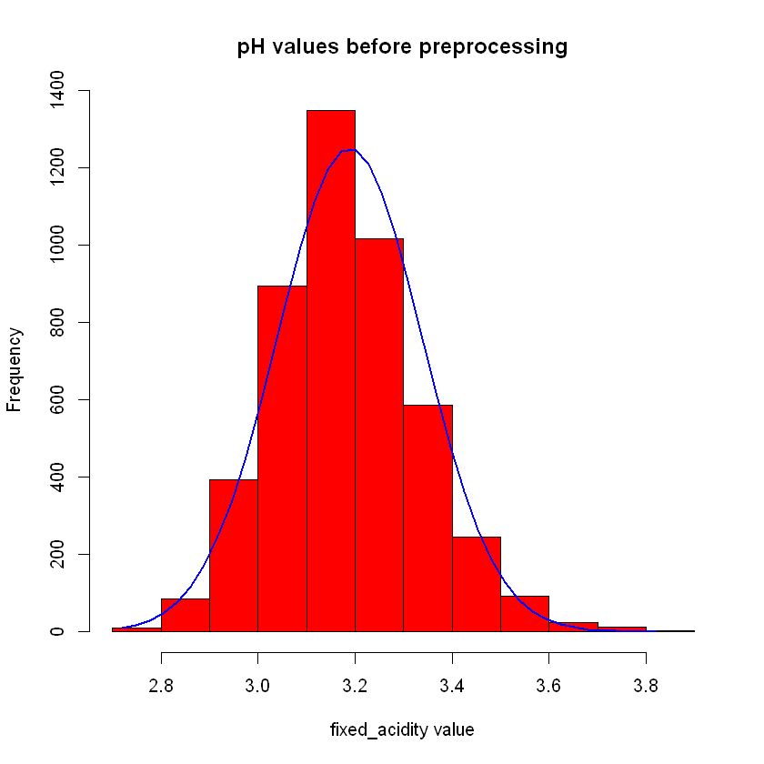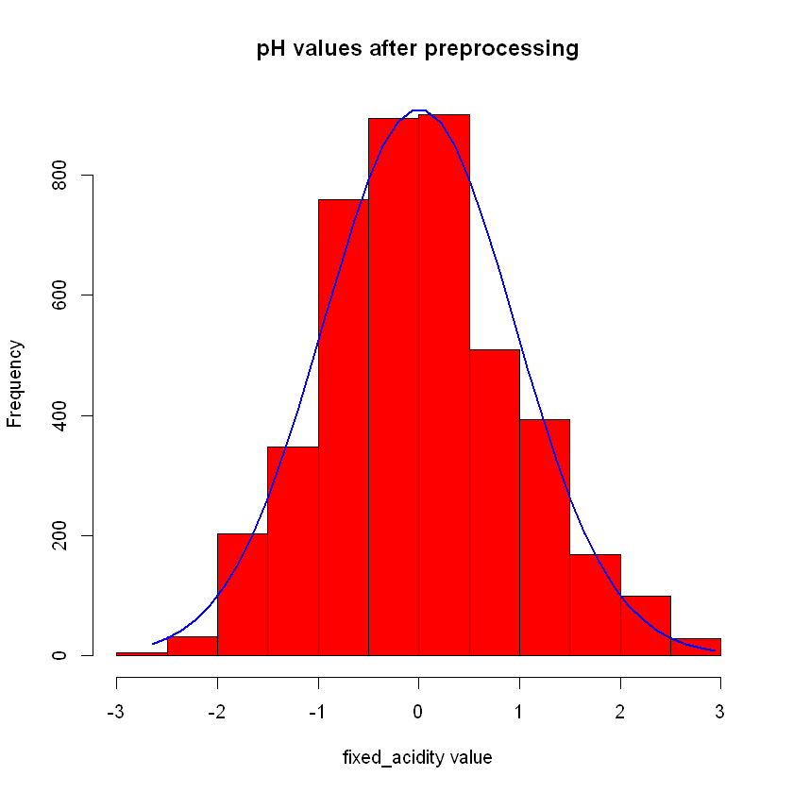

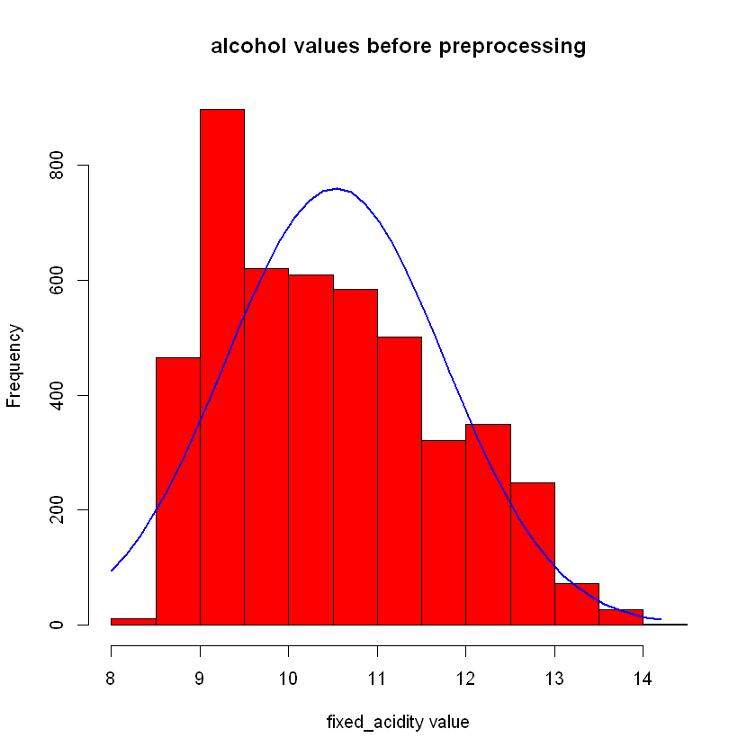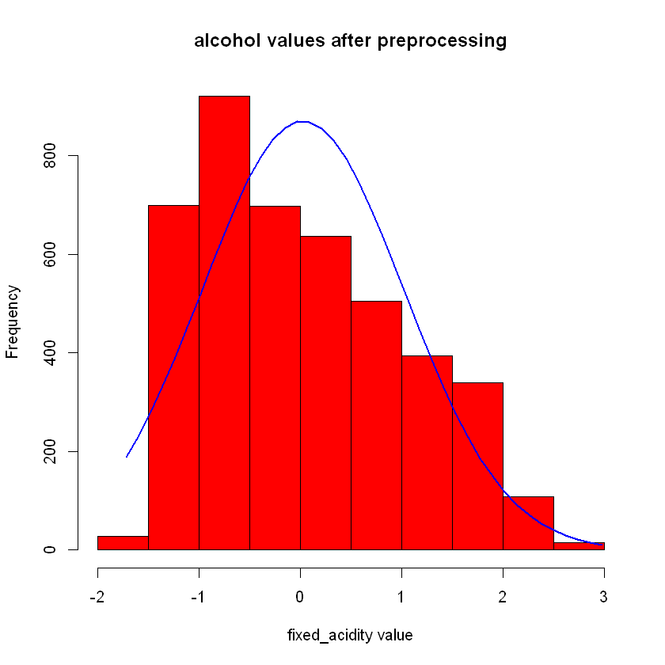

From below figure we will be able to figure it out it doesn’t affect to Quality feature distribution to Scale and the Outlier removal task.

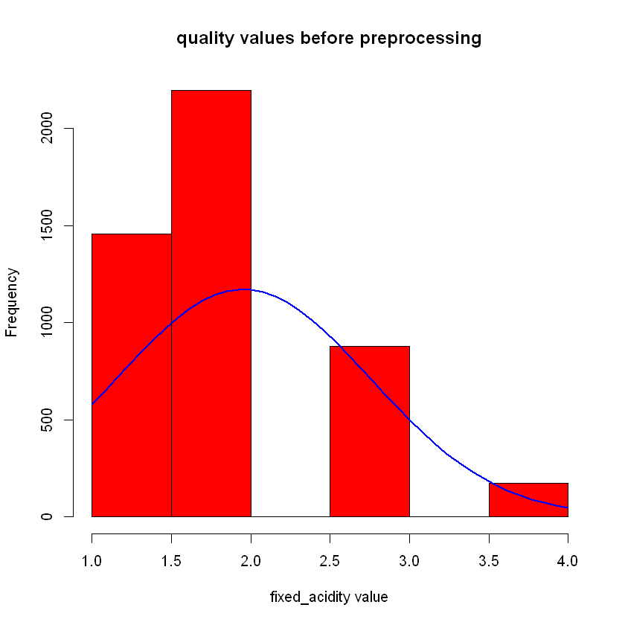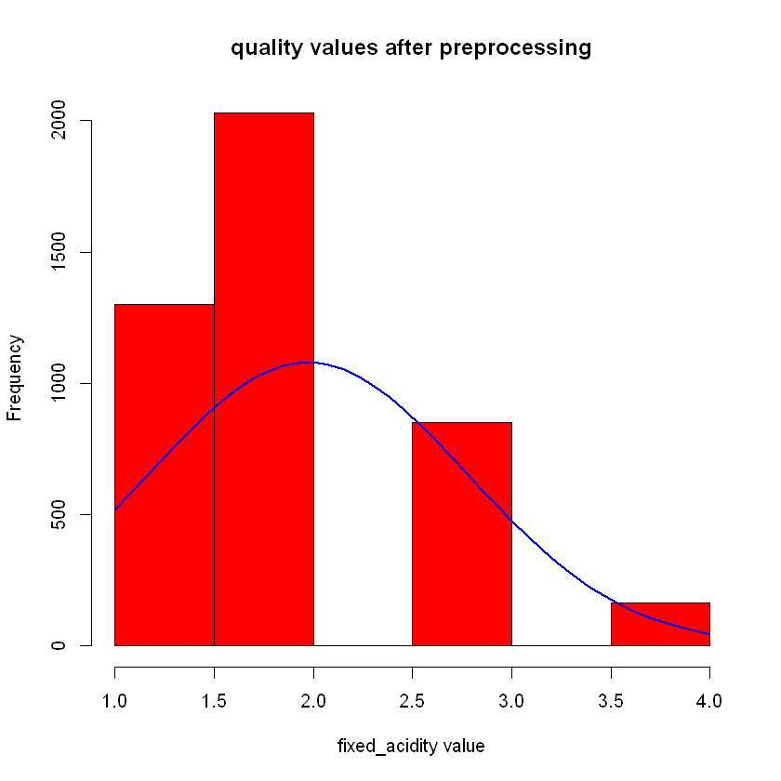

Scaling and outlier removal is very important task when doing ML use case, it will be helpful to increase performance and the accuracy of the Machine Learning Model.

## Define the number of cluster centers

**Manual Method**

This red wine dataset originally consisted with 1-10 range qualities but in this dataset, we will be able to detect 4 qualities which are 5,6,7 and 8. So there will be four clusters in this data frame and further clarification we must process with different methods and techniques to evaluate number of clusters in this red wine dataset.

**Automated Methods**

**1.NBclust**

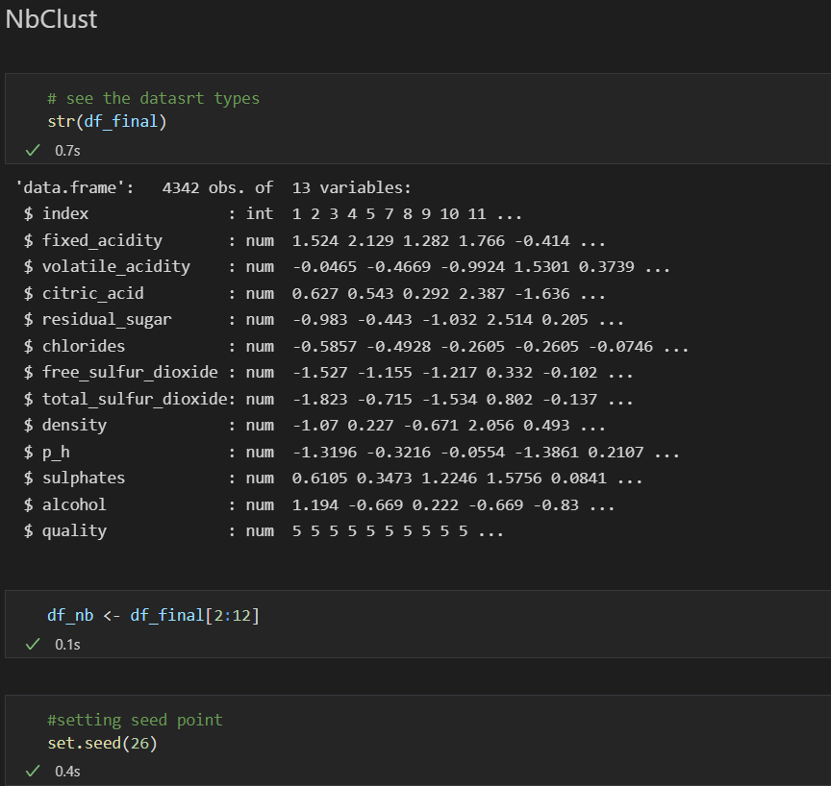

**i. Euclidian Distance**

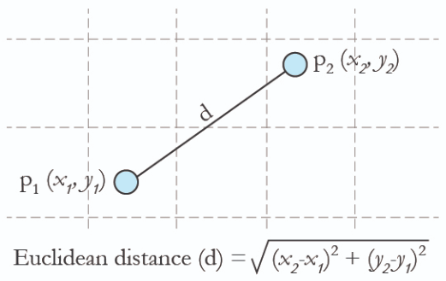



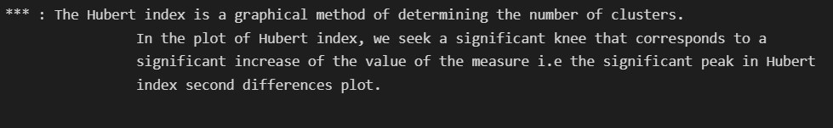

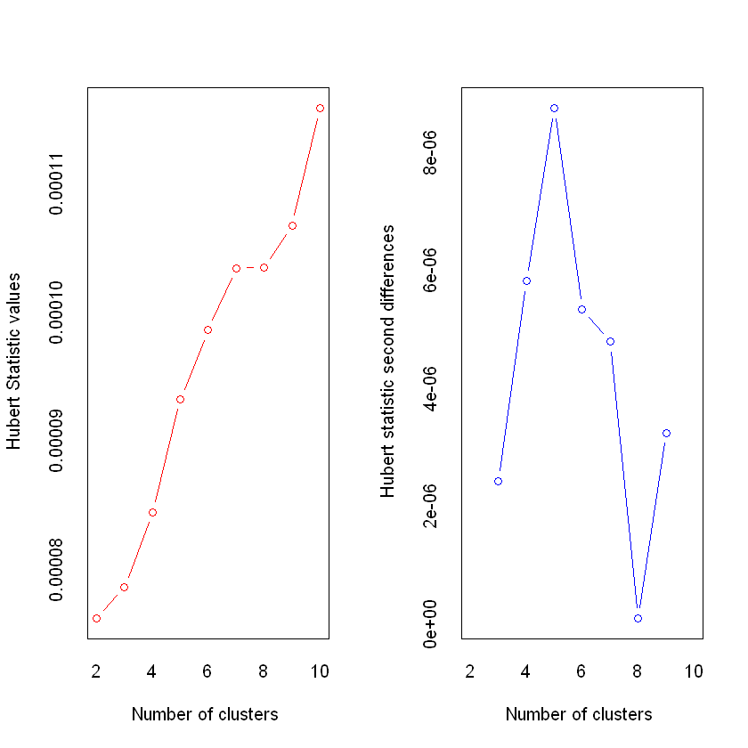

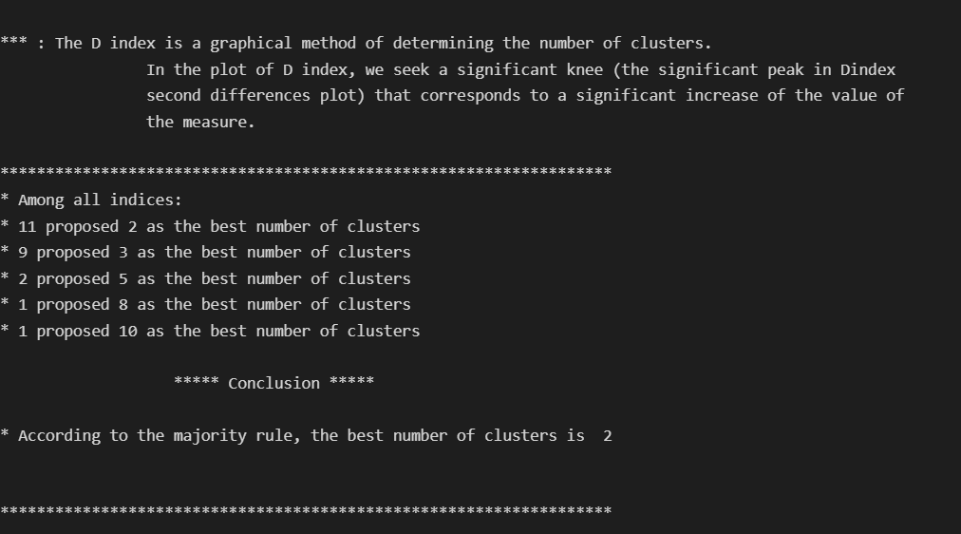

**ii. Manhattan Distance**

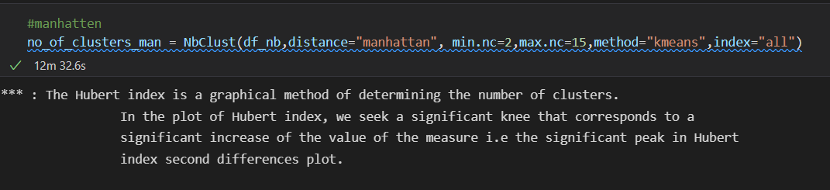

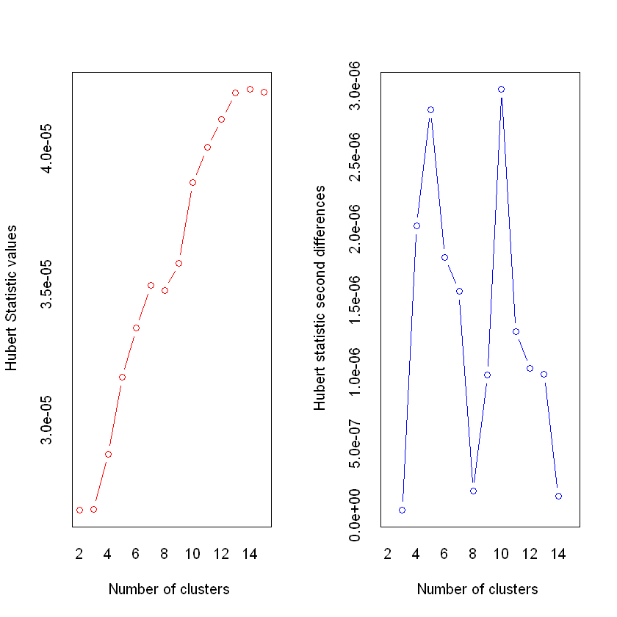

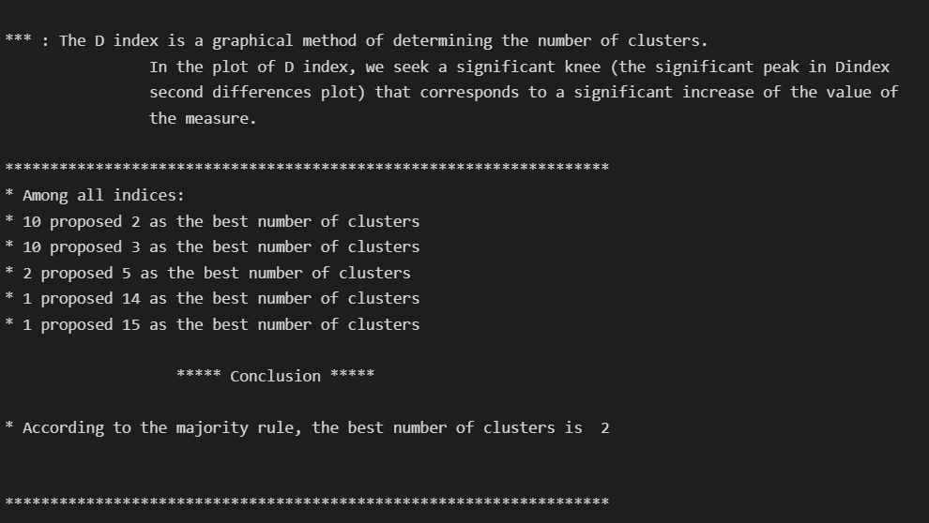

**2.Elbow Method**

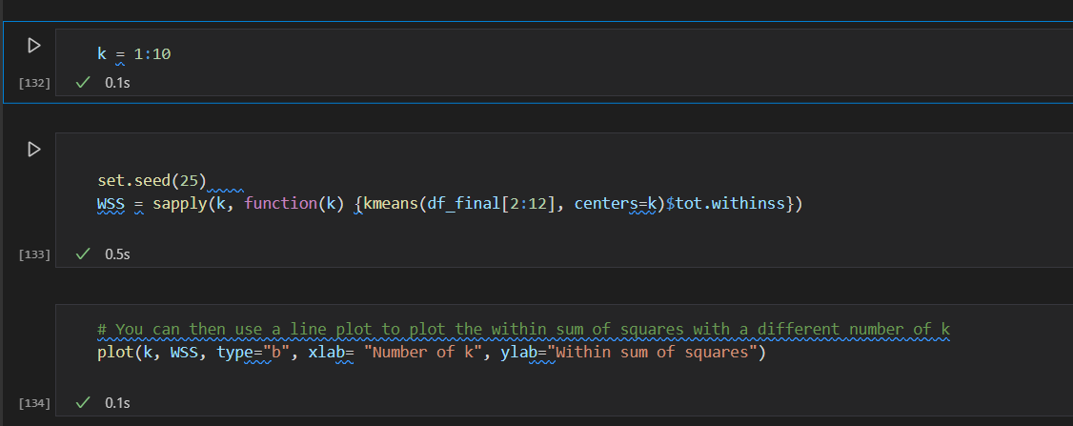

In below figure k value is initializing 1 to 10 and it will calculate the “WSS” (With in cluster Sum of Square) and return. We need to plot this output to get a better idea about that. This elbow point is the optimal cluster value of k. in below figure it is k=4

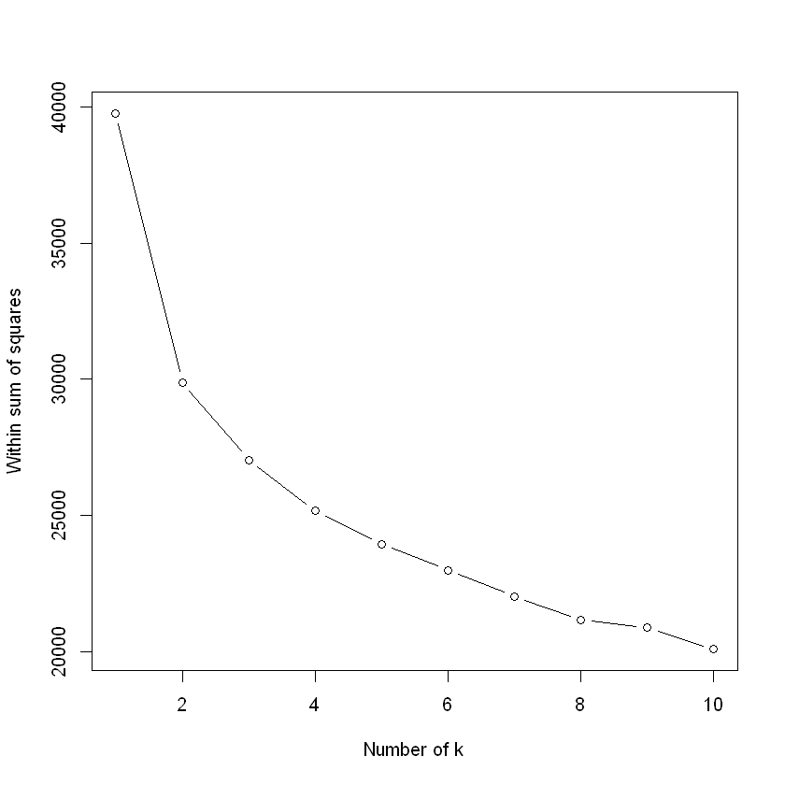

**3.Silhouette Method**

This will calculate average Silhouette with each k value and display the optimal solution.

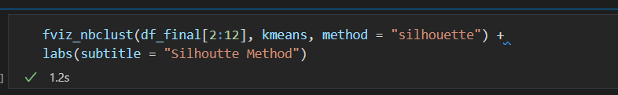

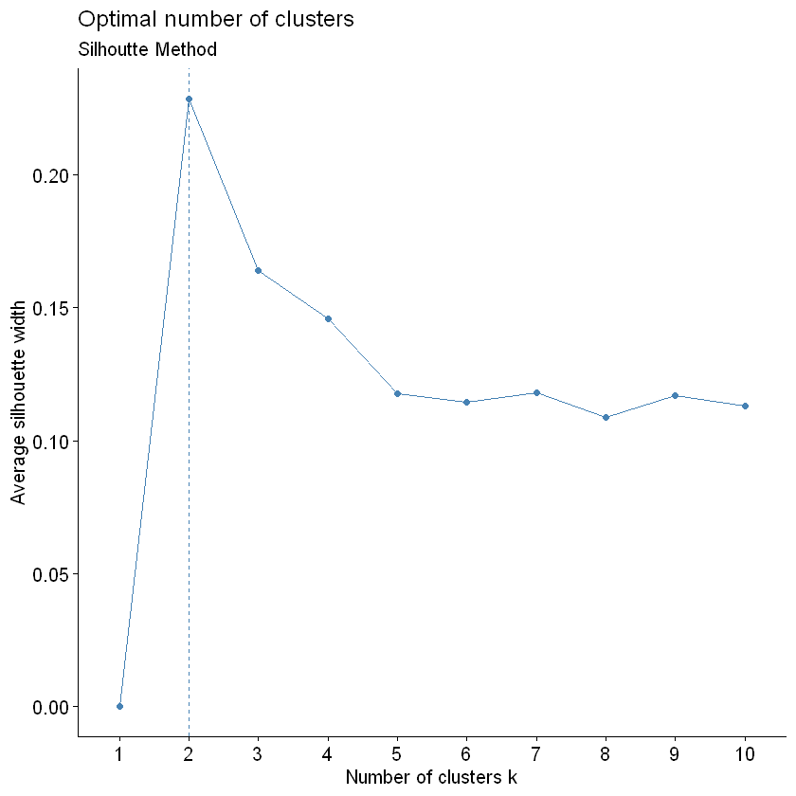

Above figure silhouette method returned optimal number of clusters as 2.

As above mentioned, automated tools most of the tools suggested k=2 for optimal clustering and elbow method suggest k=4, from this idea and as form the instructions given in the problem we will perform k-means clustering from k=2, k=3 and k=4 in next chapter and evaluate each clusters using BSS/TSS and confusion matrix.

## K-means Clustering

From above chapter we discussed some automated and manual methods to select optimal cluster amount for k-means algorithm, in this chapter we will experimenting k=2, k=3 and k=4 as number of clusters and evaluate which is the “winning” clustering approach.

To evaluate this process, we use WSS (Between cluster Sums of Square) over TSS (Total cluster Sums of Square) and Confusion Metrix calculations such as accuracy/precision and recall.

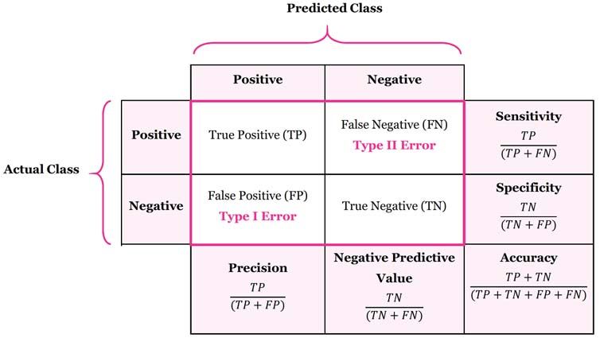

Figure : confusion matrix

**K=2**

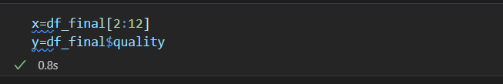

For further analysis we will divide data frame into x and y, x: all numerical features / y: quality.

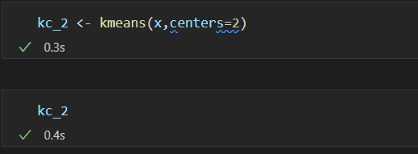

Above figure shows executing k-means inbuilt function in r with data and number of clusters. Then we will see the results.

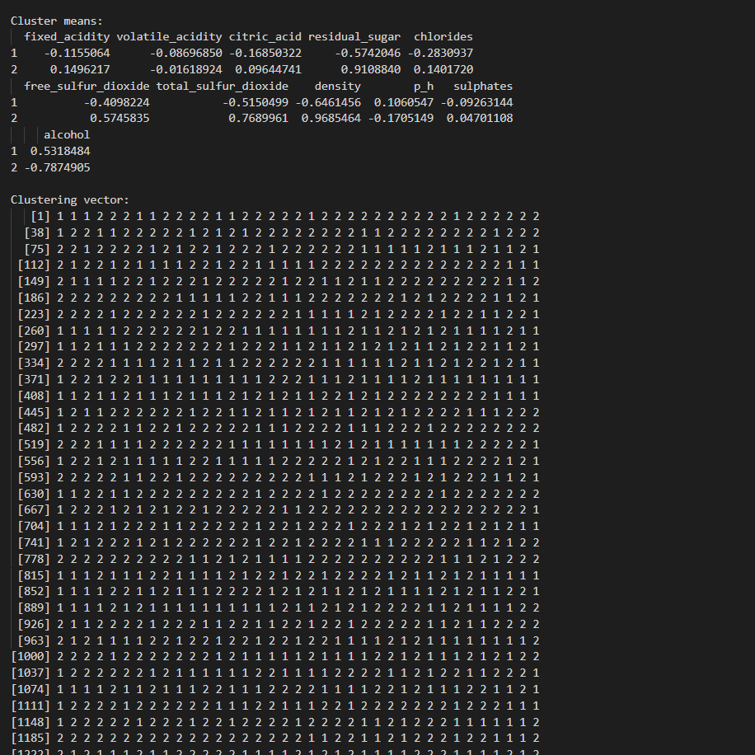

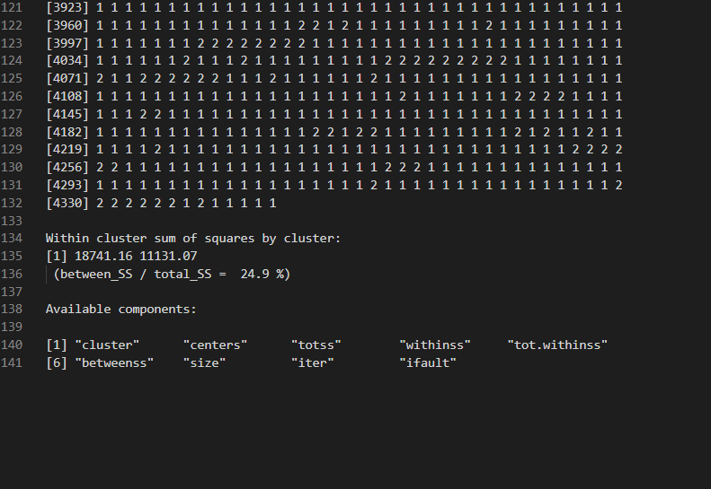

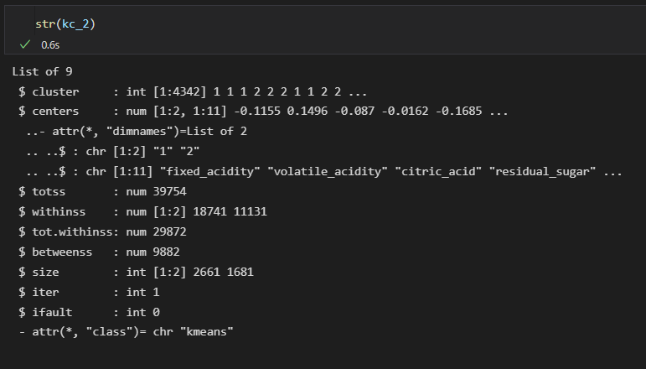

Then we will be able to create confusion matrix, below figure shows the confusion matrix,

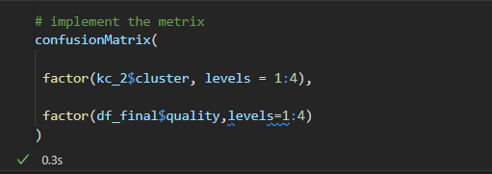

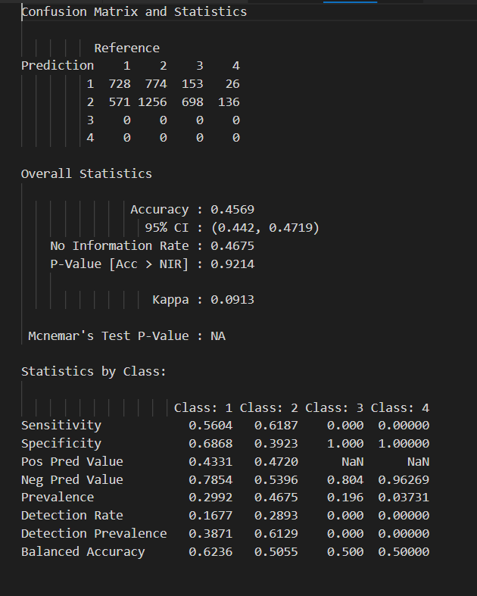

Then we visualize this result with the help of visualization libraries.

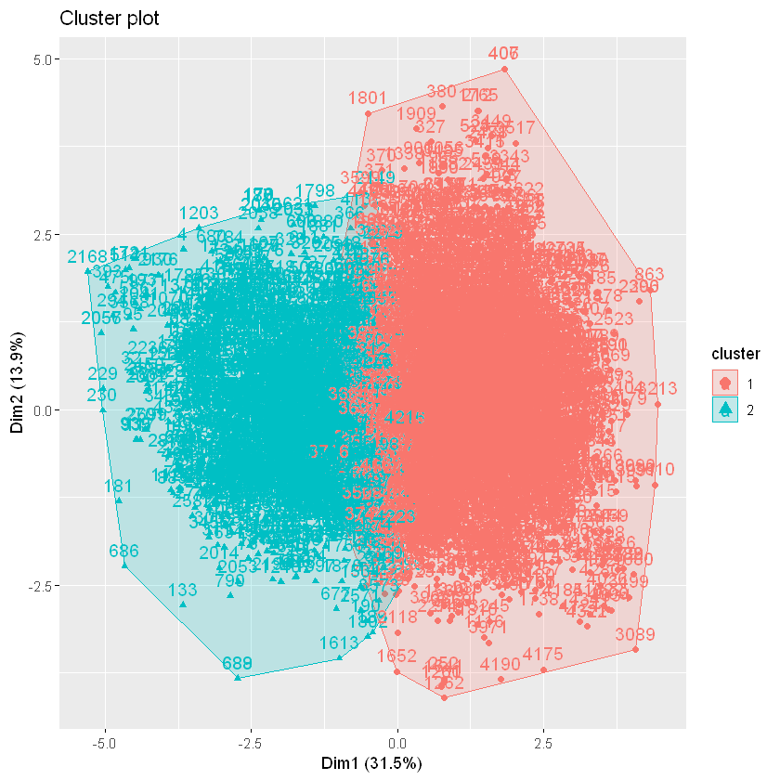

**K=3**

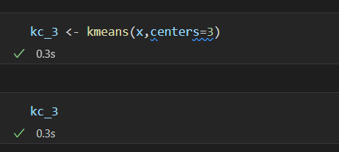

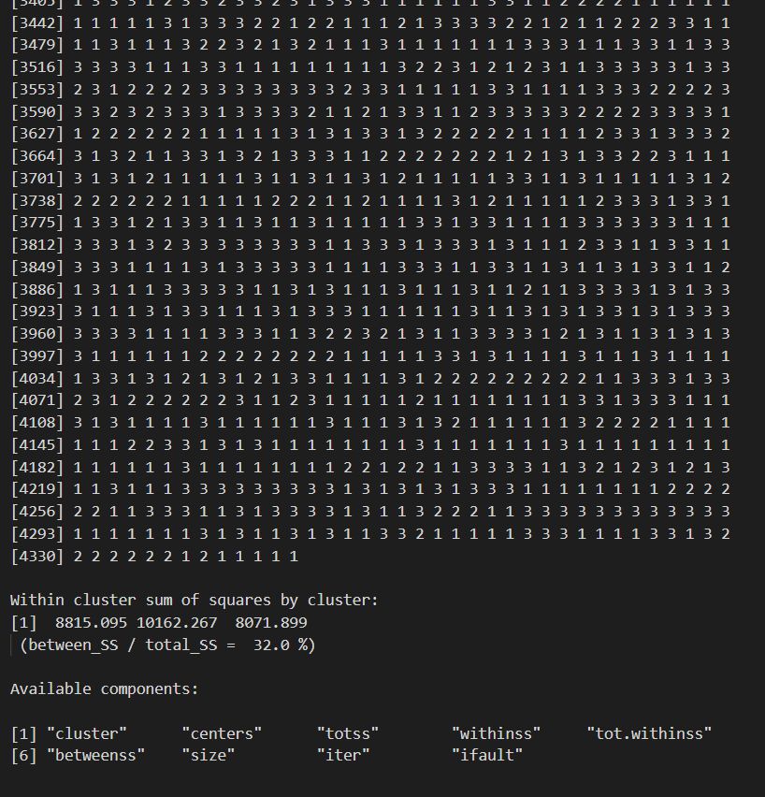

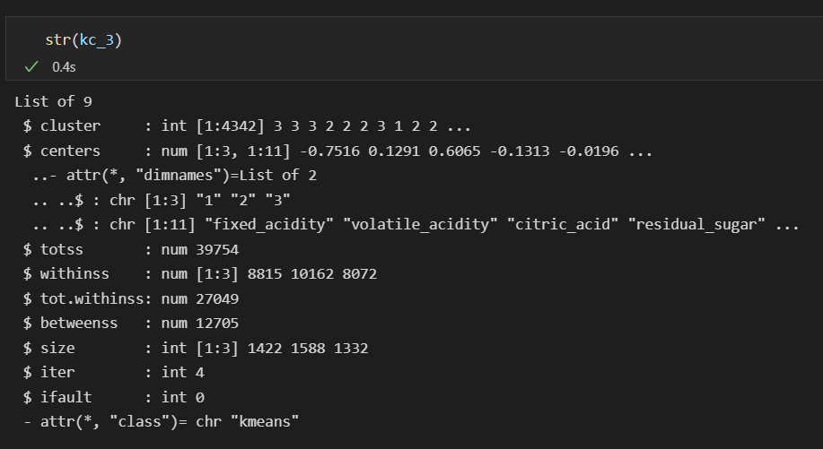

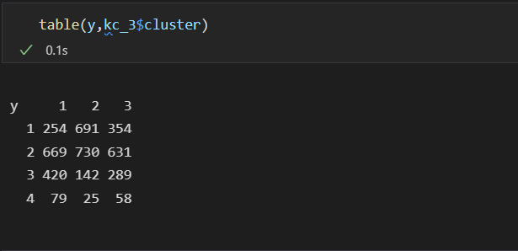

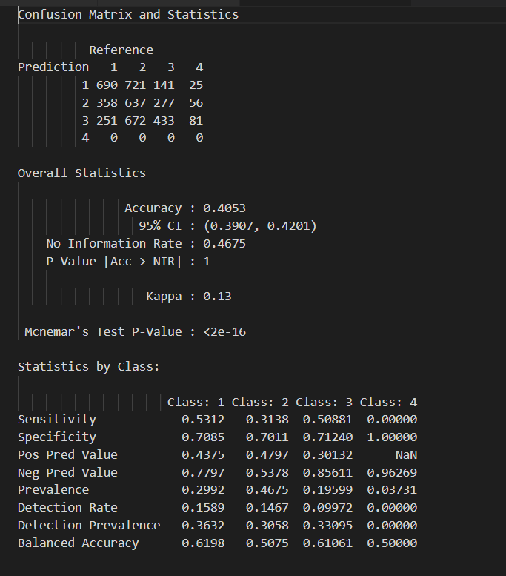

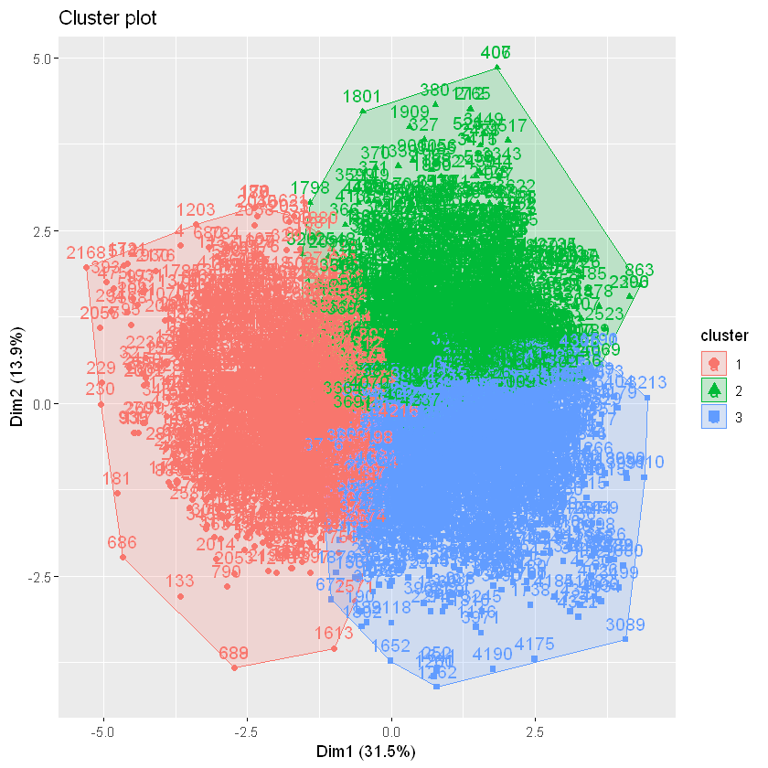

**K=4**

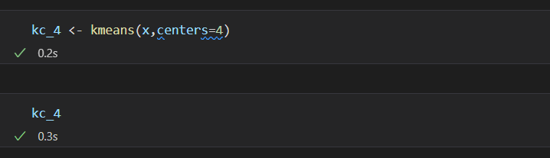

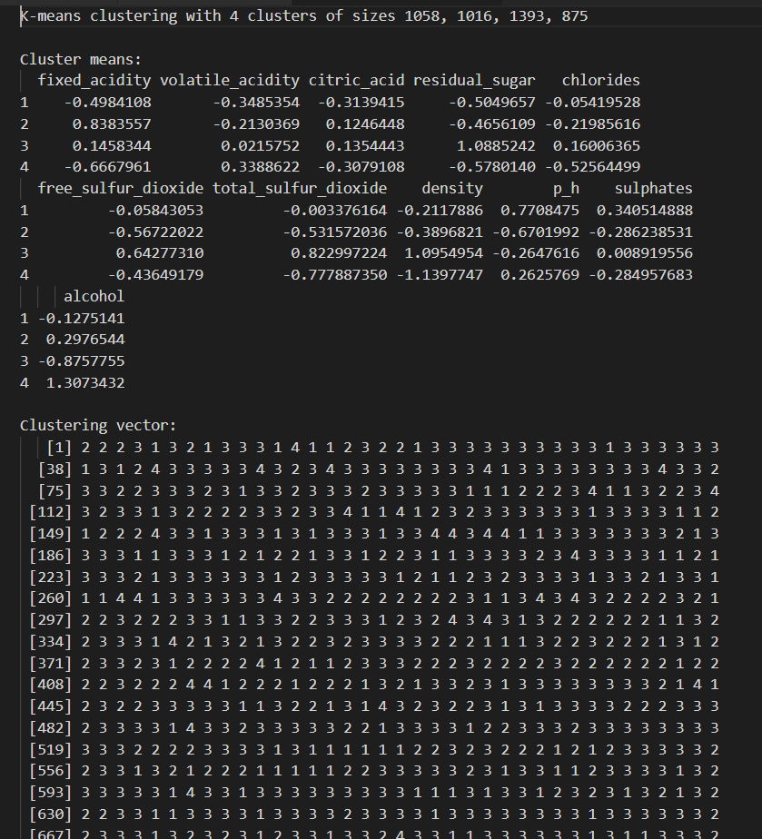

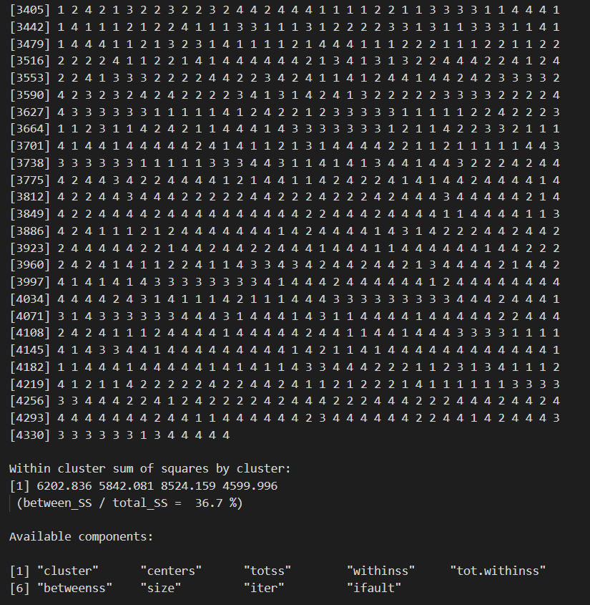

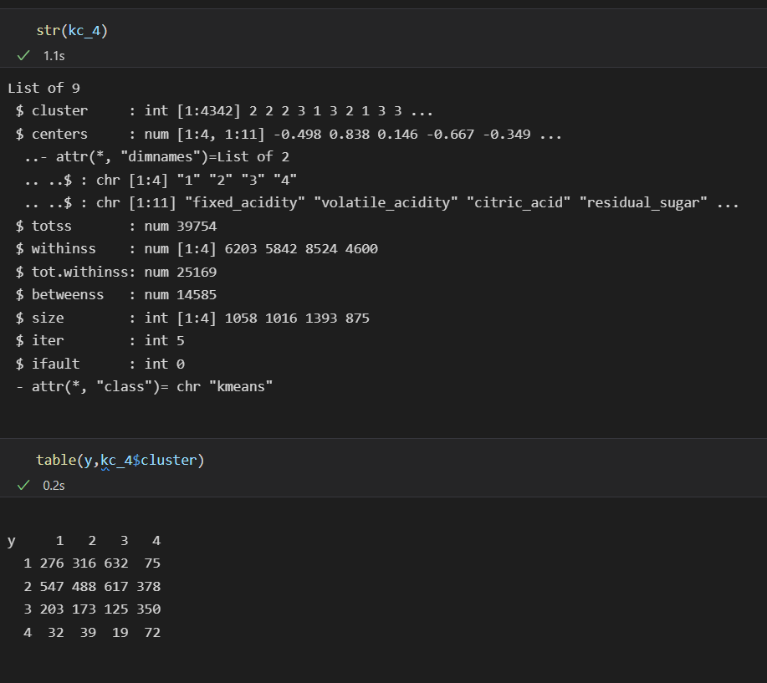

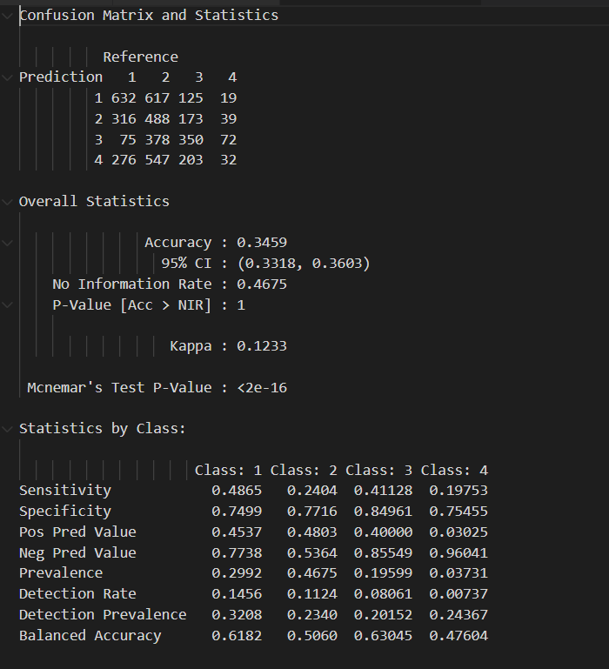

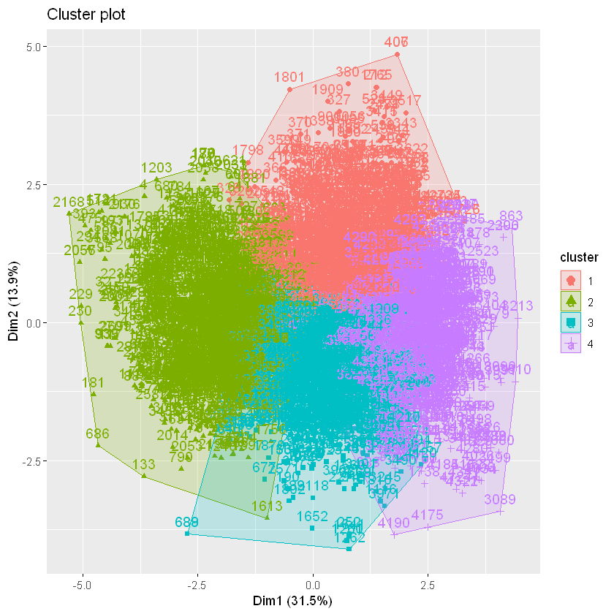

Visualizing all together,

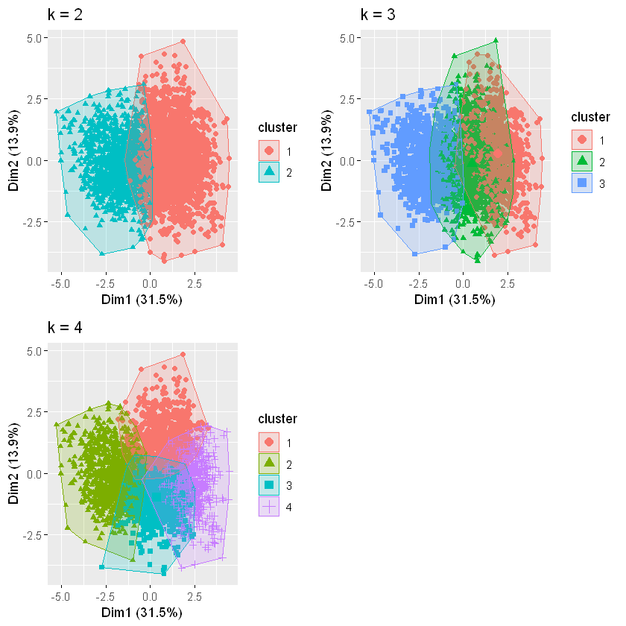

**Compression Table**

Class1 = quality 5

Class2 = quality 6

Class3 = quality 7

Class4 = quality 8

|  |  |  |  |  |
| --- | --- | --- | --- | --- |
| Cluster amount | BSS/TSS | Accuracy | Recall/Sensitivity | Specificity |
| k=2 | 24.9% | 45.69% | class1:56.04% class2:61.86% | class1:68.68% class2:39.23% |
| k=3 | 32.0% | 40.53% | class1:53.12% class2:31.38% class3:50.88% | class1:70.85% class2:70.11% class3:71.24% |
| k=4 | 36.7% | 34.59% | class1:48.65% class2:24.04% class3:41.12%  class4:19.75% | class1:74.95% class2:77.16% class3:84.96%  class4:75.45% |

**Define “winning” cluster**

From above automated tools form previous chapter gives most optimal cluster is k=2 and after experimenting with different k values form this chapter, we will be able to see accuracy was changing time to time when executing the code with different times, but BSS/TSS percentage didn’t changed. For considering about BSS/TSS percentage reflect good fit of the clusters. The highest BSS/TSS percentage is k=4 and good to have as 4 clusters because we are dealing with some quality factor and if we consider as k=2 there are lots of different variations of wine samples may be together as same cluster. Because of those reasons I will consider k=4 is the “winning” cluster for this dataset and clustering is subjective and it can be use as different purposes.

**Evaluation Metrics,**

After we are doing Machine Learning Task, we must evaluate our results, so for that reason we use some evaluation metrics,

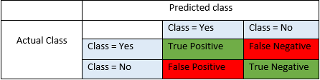

When we have labeled dataset to perform our task after the prediction, we will be able to define above matrix this is call confusion matrix,

**True Positives**: these values correctly predicted positive by model and actual class of predicted value is also yes

**True Negatives**: these values correctly predicted negative by model and actual class of predicted value is also no

**False Positives**: when actual class is no, and predicted class is yes

**False Negative**: when actual class in yes, and predicted class is no

Accuracy:

Accuracy is the most common performance measure, and it is simply a ratio of correctly predicted values vs total observations.

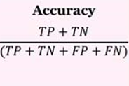

Precision:

Ratio of correctly predicted positive values to the total predicted positive observations

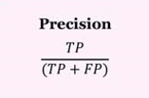

Recall (Sensitivity):

Ratio of correctly predicted positive observations to all observation in actual class.

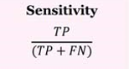

## Dimensionality Reduction (PCA)

In this chapter we will reduce the intentionality of our dataset and evaluate which features are mostly affect to the quality of the wine sample and perform k-means “winning” clustering number for new dataset which is reduced dimensionality by using PCA.

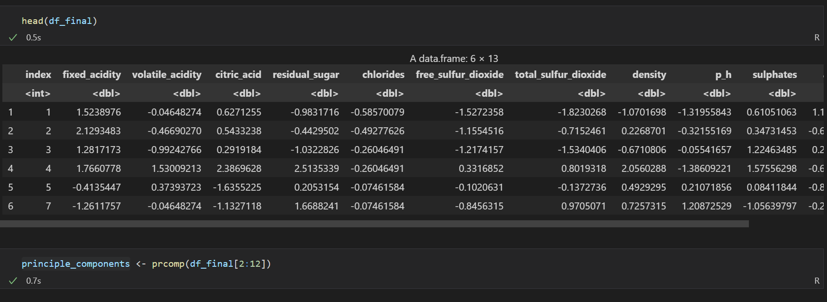

Above figure shows the dataset used for PCA analysis and the PCA function with numerical features.

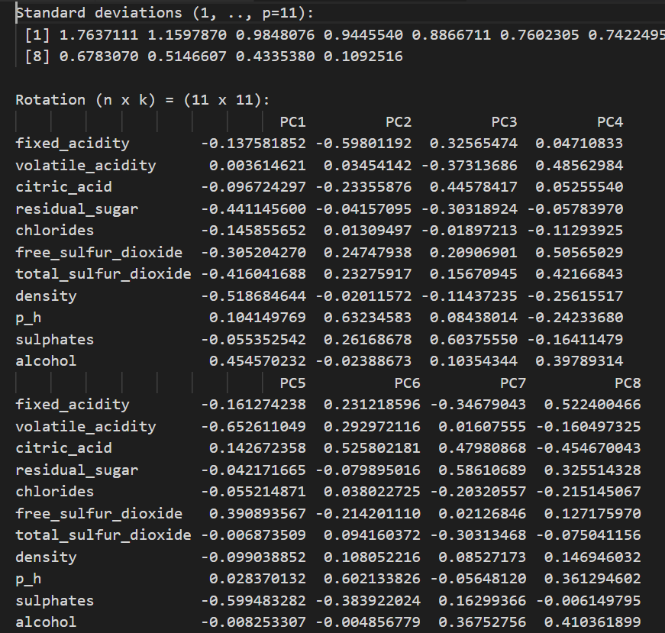

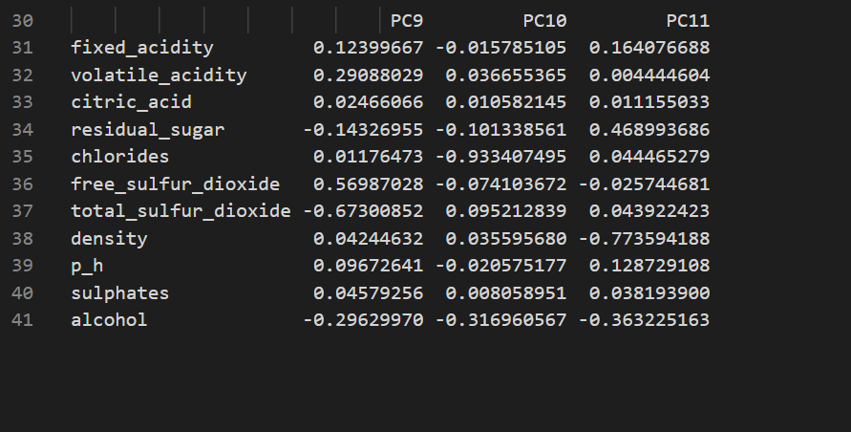

Below figure shows summary details of principle components in our data frame

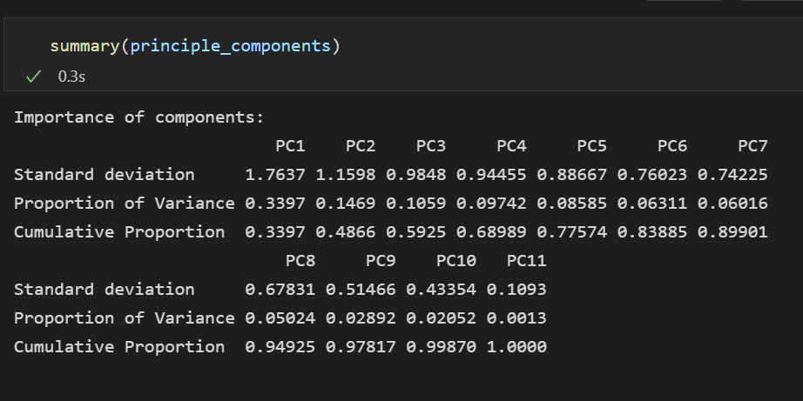

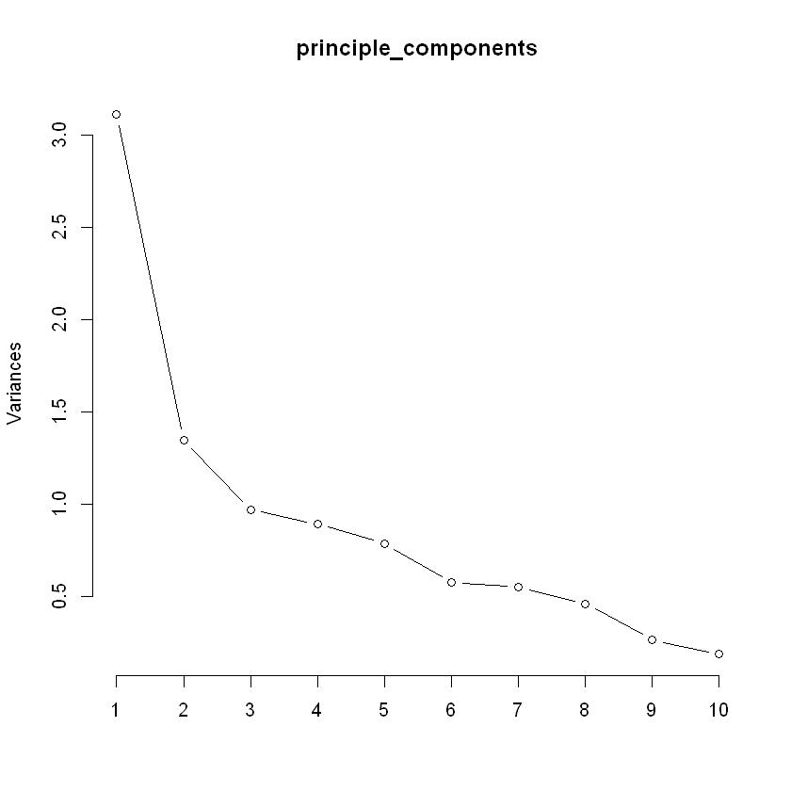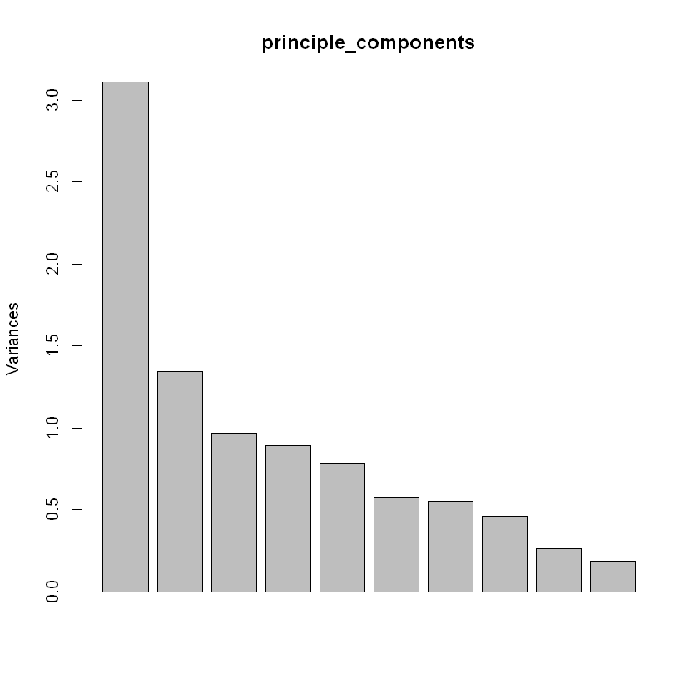

We can pot PCA’s to get some idea about it, but it’s difficult to get exact idea about that because we are plotting 2d graph and this PCA’s in various 12 dimensions.

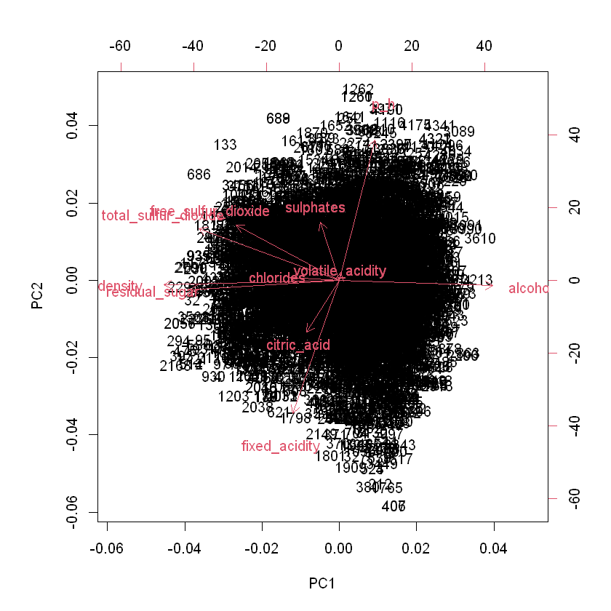

Changing the Scale,

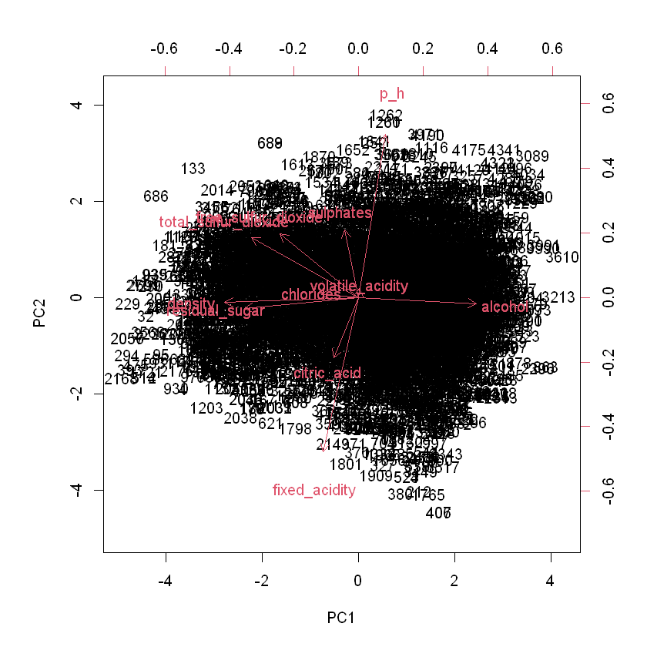

Merging new columns with data frame,

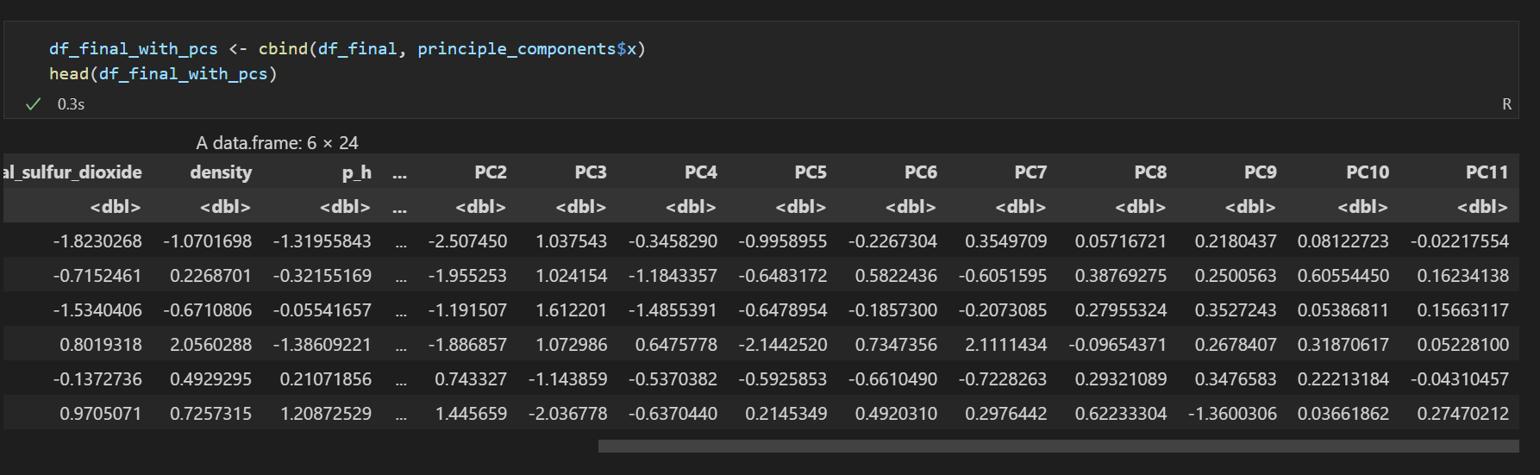

Plotting cumulative score > 96% features (PC9, PC10, PC11),

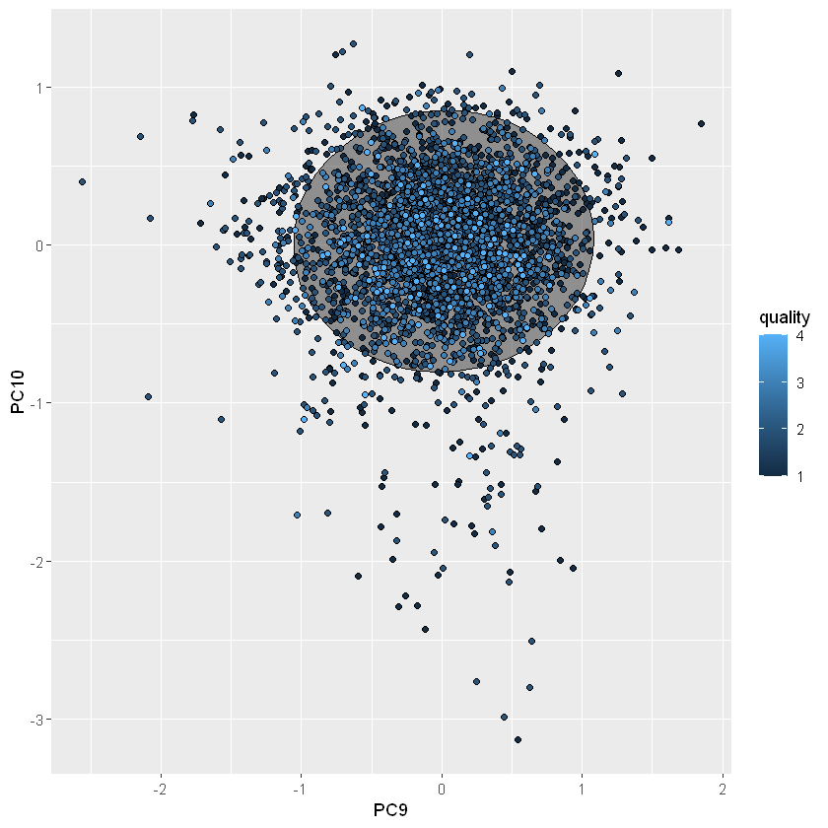

**K-means Clustering**

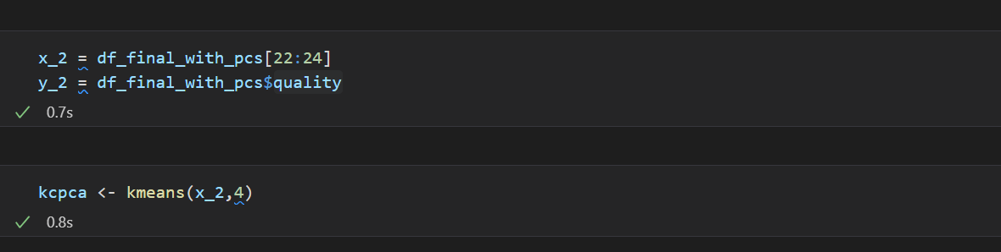

Above figure shows getting data and labels to do clustering and perform clustering with k=4

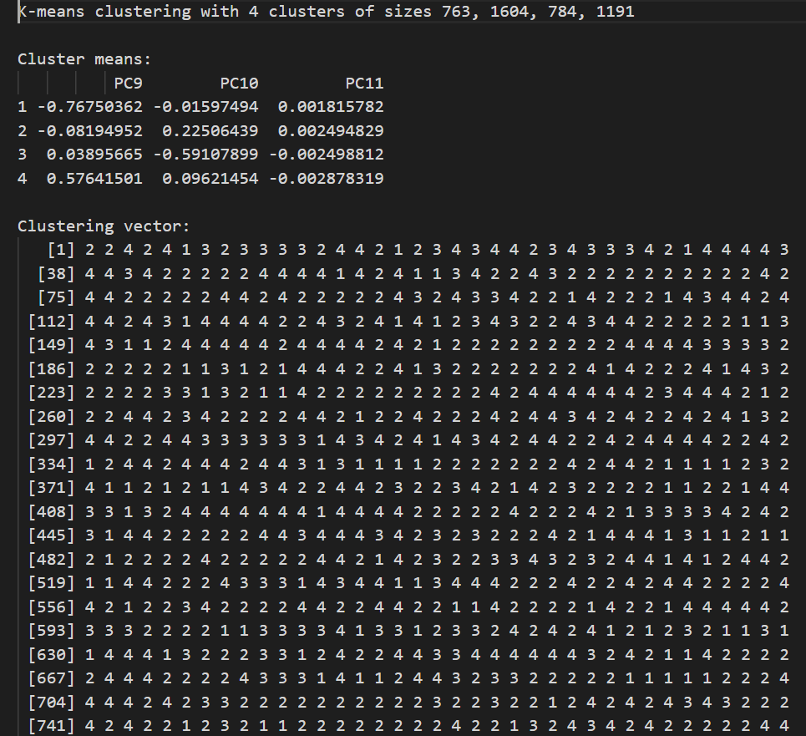

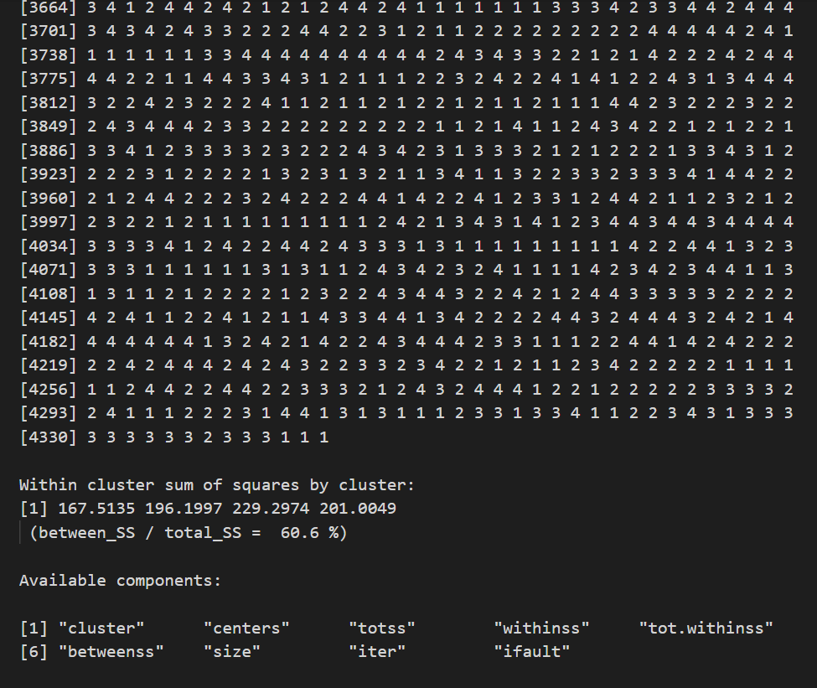

We can see BSS/TSS is improved than previous chapter and it tells this clusters are fitted well.

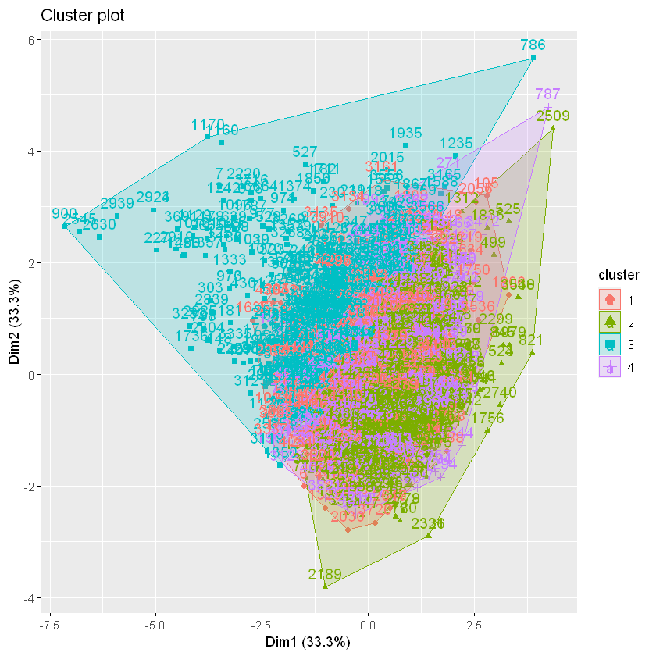

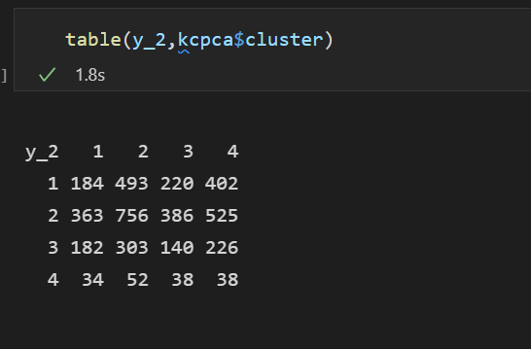

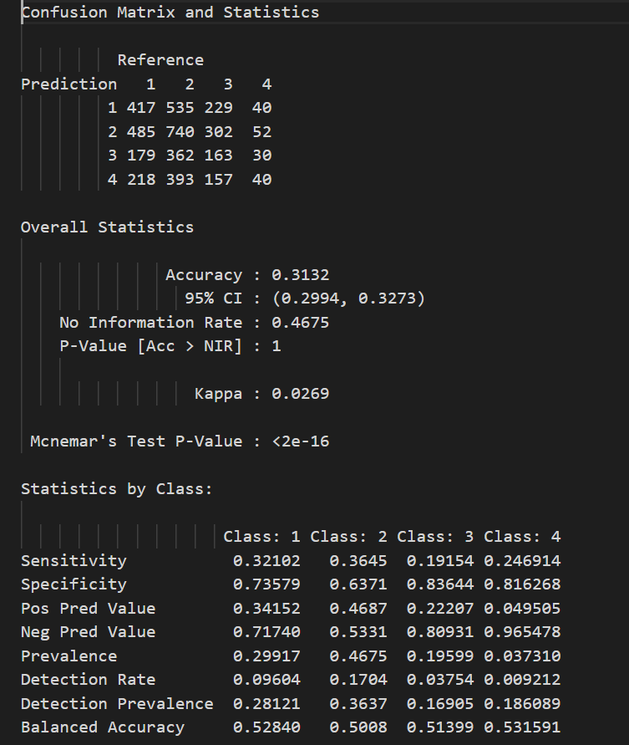

In previous chapter we perform k-means clustering with the original features of the dataset and at ‘winning” cluster value we got BSS/TSS as 36.7% then after we performed PCA to reduce the dimensionality of the dataset and we was able to reduce the dimension of the dataset. Them after we performed k-means clustering and got BSS/TSS=60.6% so we can see in 2nd stage we got more fitted clusters with the new dataset after clustering, while k-means is an unsupervised machine learning algorithm and reduce the dimensionality of the dataset affected to the improvement of the machine learning algorithm’s performance.

**Conclusion**

When we are dealing with Machine Learning first, we must clean the dataset and must do some preprocessing before dealing with machine learning. Then it will be very important to increase the performance of the Machine Learning model and after the machine learning stage we need to evaluate our outputs with some methods. Following these steps in sequency help to smooth the machine learning journey.

# Time Series Forecasting

As the given instructions we must perform time series forecasting on energy data. We must introduce new input features from given data and crate some previous time period data to perform this task by changing the network architecture and validate by using RMSE, MSE and MAPE.

**Time Series Forecasting**

Time series forecasting is the Machine Learning technique which is used to make scientific predictions

using Historical time stamped data. Time Series Forecasting involves building models through historical

analysis and using them to make observations and drive future strategic decision-making.

**Energy Forecasting Analysis**

Basically, Energy Forecasting Analysis is a technique to predict future energy needs to archive demand and

Supply equilibrium. In this problem we have historical electricity consumptions data in three hours and we

Must predict next day electricity consumption for 11th hour.

In this domain several techniques were used by researchers which includes some traditional methods such as

Regression, Time Series, Artificial Neural Networks (ANNs), Support Vector Machines (SVM), fuzzy logic

and Gray Prediction. In this use case we need to construct Multi-Layer Perceptron Neural Network with Autoregressive approach.

**Auto Regressive Models**

When we use multiple regression model, we forecast the variable of interest using a linear combination of predictors, but in Autoregressive models we forecast the variable of interest using a linear combination of past values of the variable and the error term. AR models are named with the number of previous time period terms. Thus, an autoregressive model of order of p can be written as,

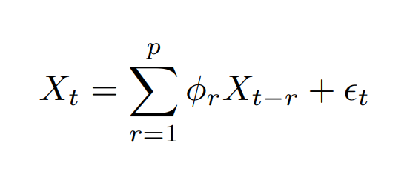

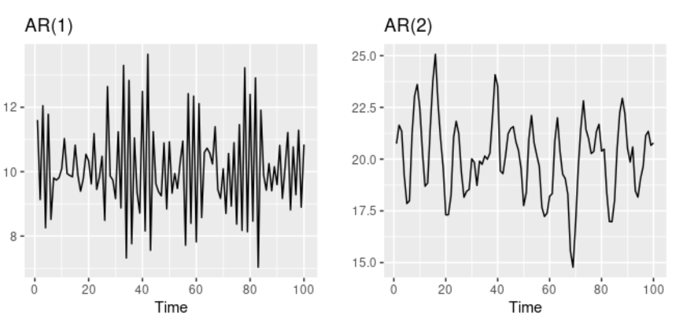

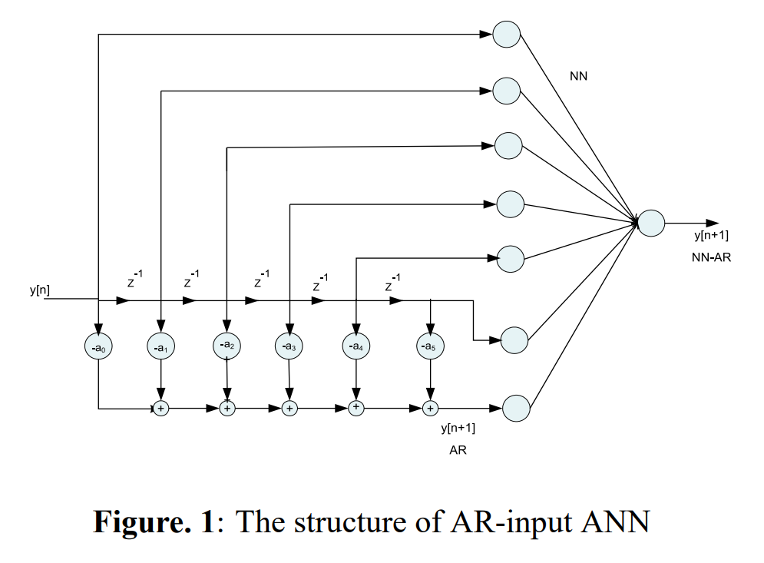

When we use this autoregressive approach to this problem, we need to construct ANN’s with time delayed values of the electricity loads. As per the instructions we will be able to use (t-4) level for experiments and week before values (t-7) also can be use specifically for electricity consumption forecast.

Steps followed in this problem.

1. Construct time delayed inputs
2. Normalization
3. One layer model experimenting with various layer nodes and input sets
4. Two-layer model experimenting with various layer nodes and input sets
5. Choosing best models from above stages
6. Experimenting with learning rate with best models
7. Choose best model
8. Prediction with best model and conclusion

## Construct time-delayed values

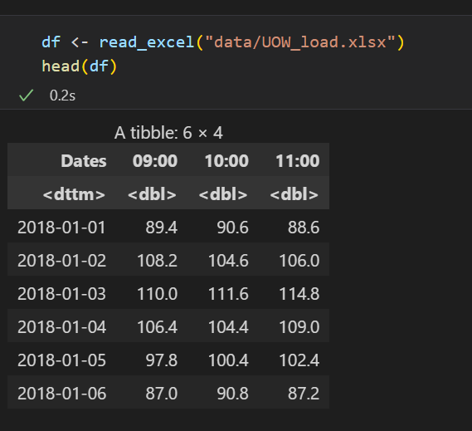

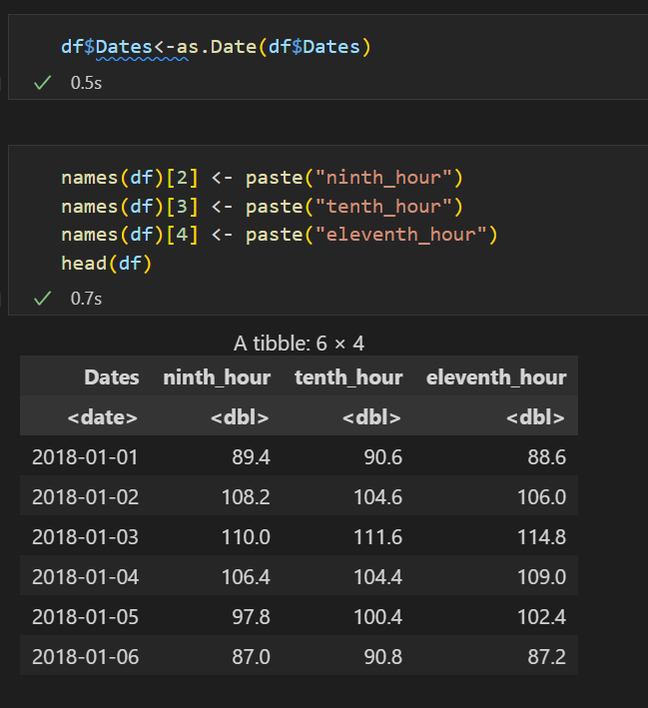

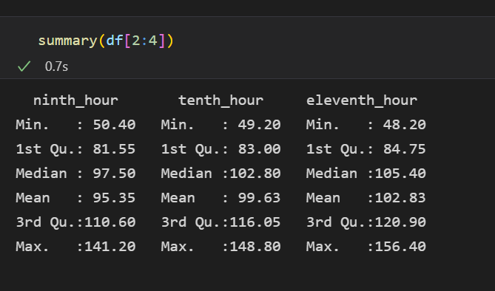

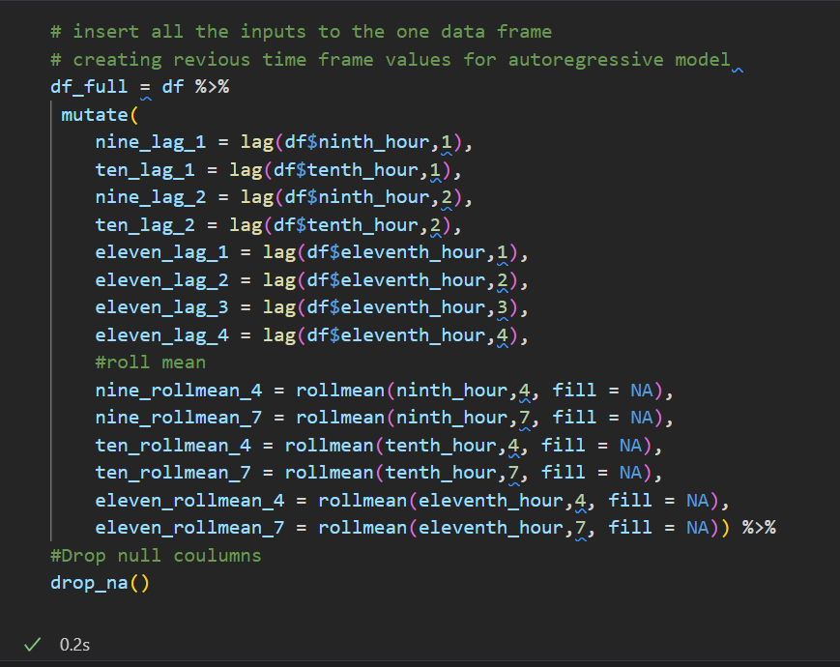

Above figure shows creating time-delayed values using lag.

Defining various input vector sets for further experiments.

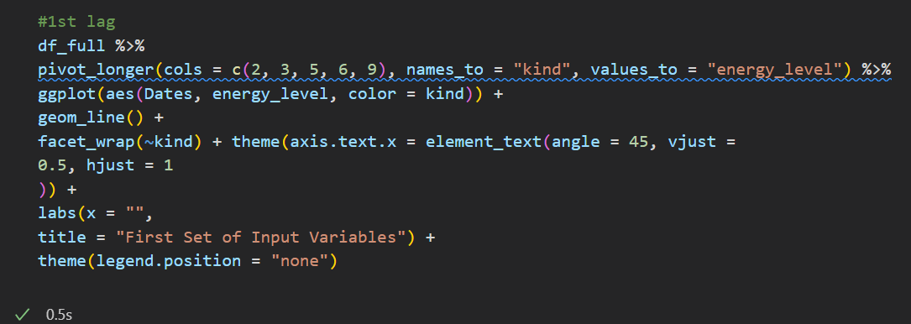

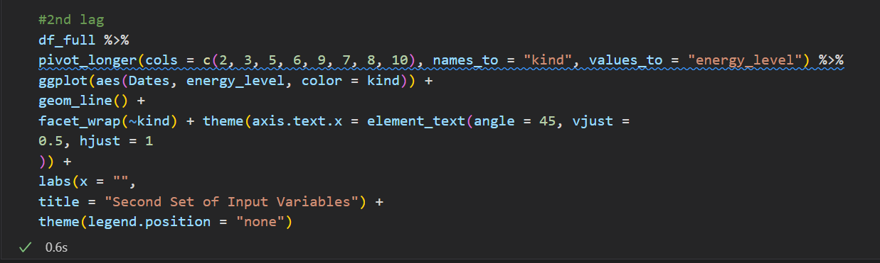

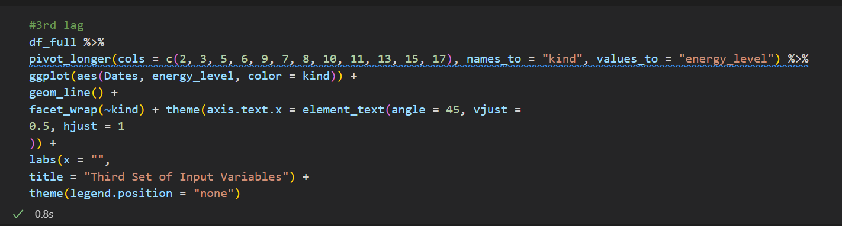

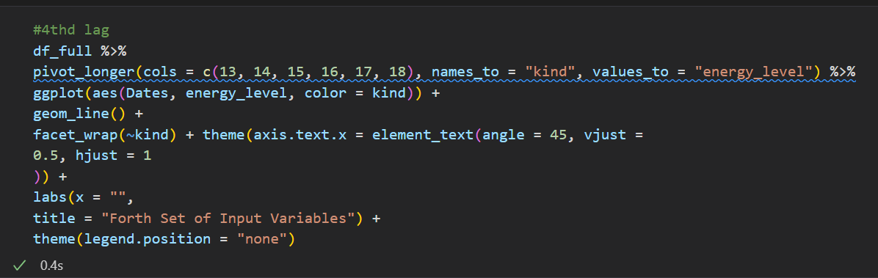

Above code snippets used to visualize four different input sets used to experiments.

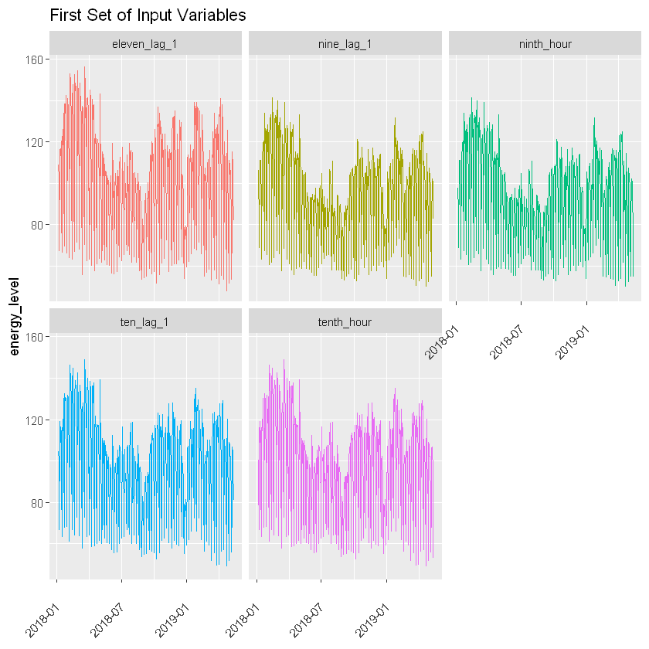

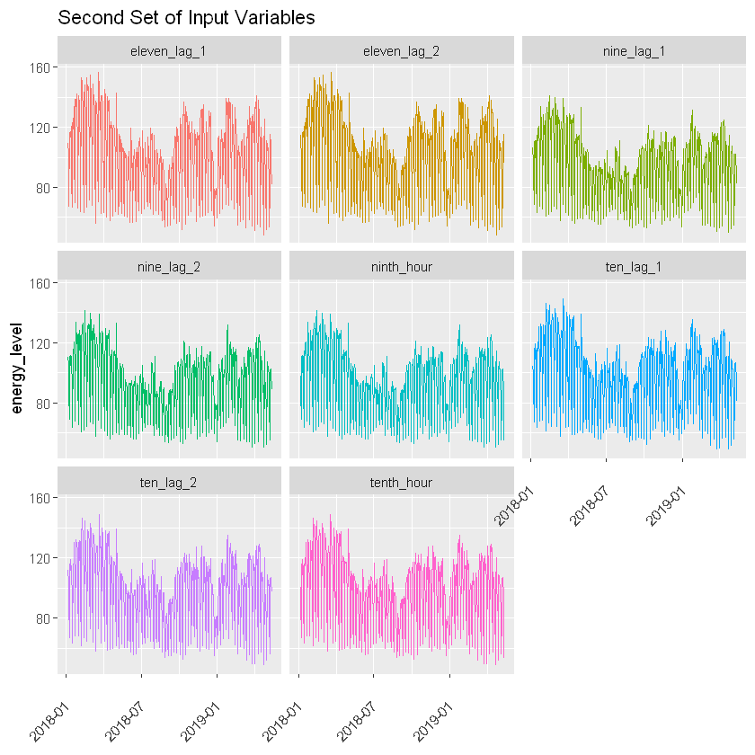

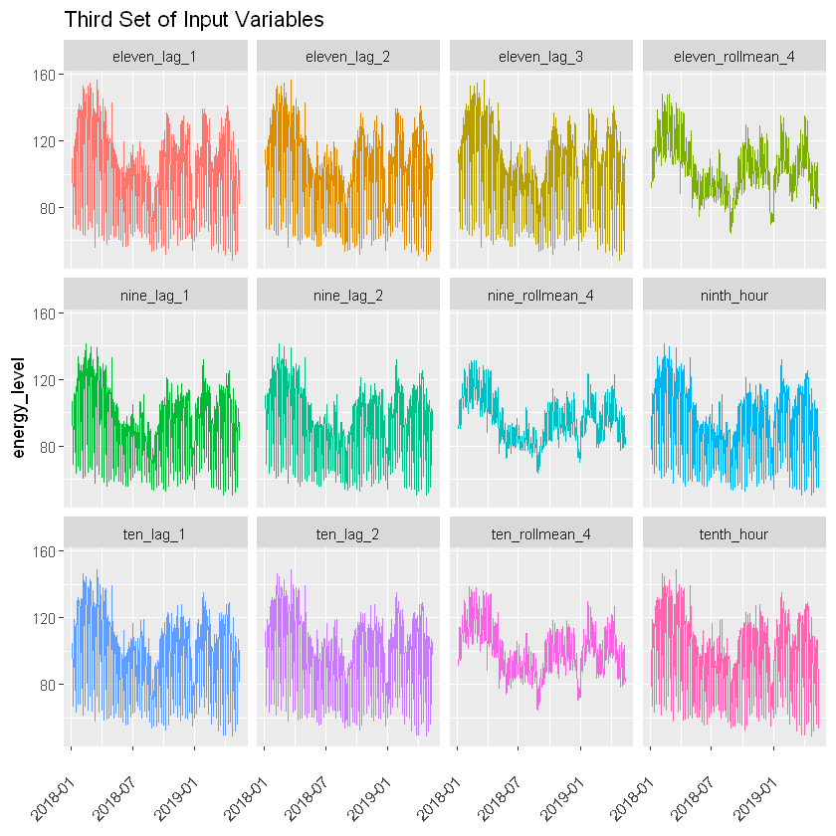

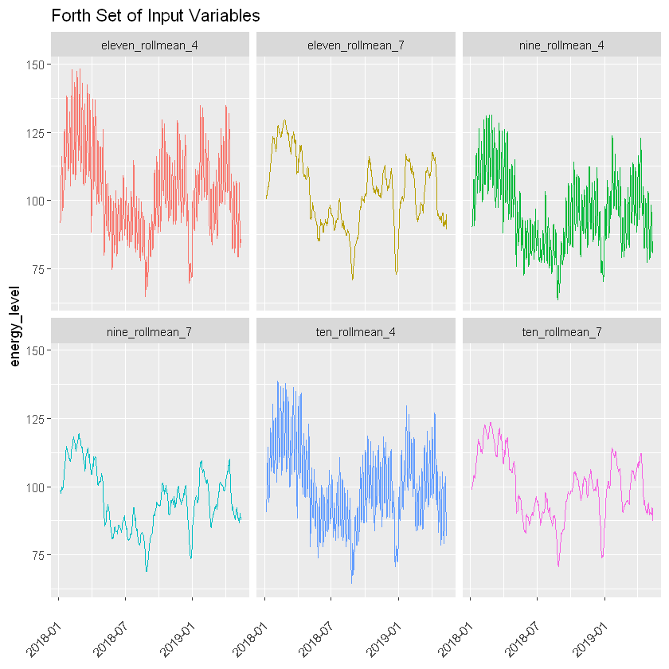

## Data Normalization

Data Normalization is a rescaling of data from original range to so that all values are within the 0 and 1.

In this use case we used min-max normalization.

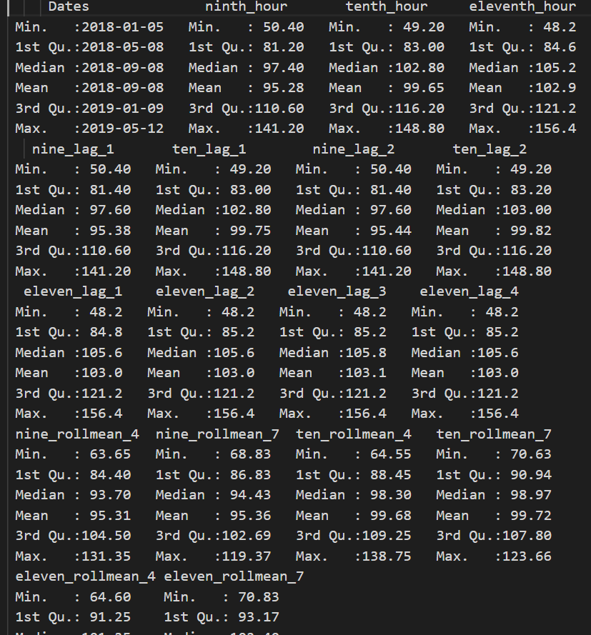

Above figure shows summary of the dataset before normalizing.

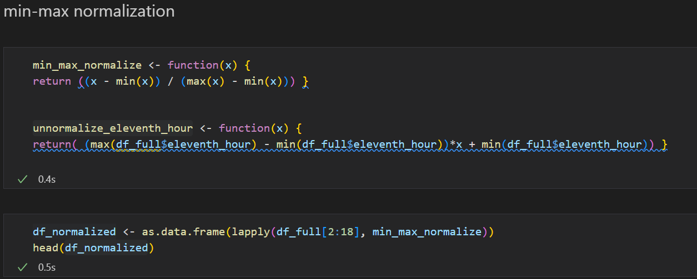

Above figure shows normalize and unnormalize functions and applying normalization for the dataset. And let’s see some summary of the data.

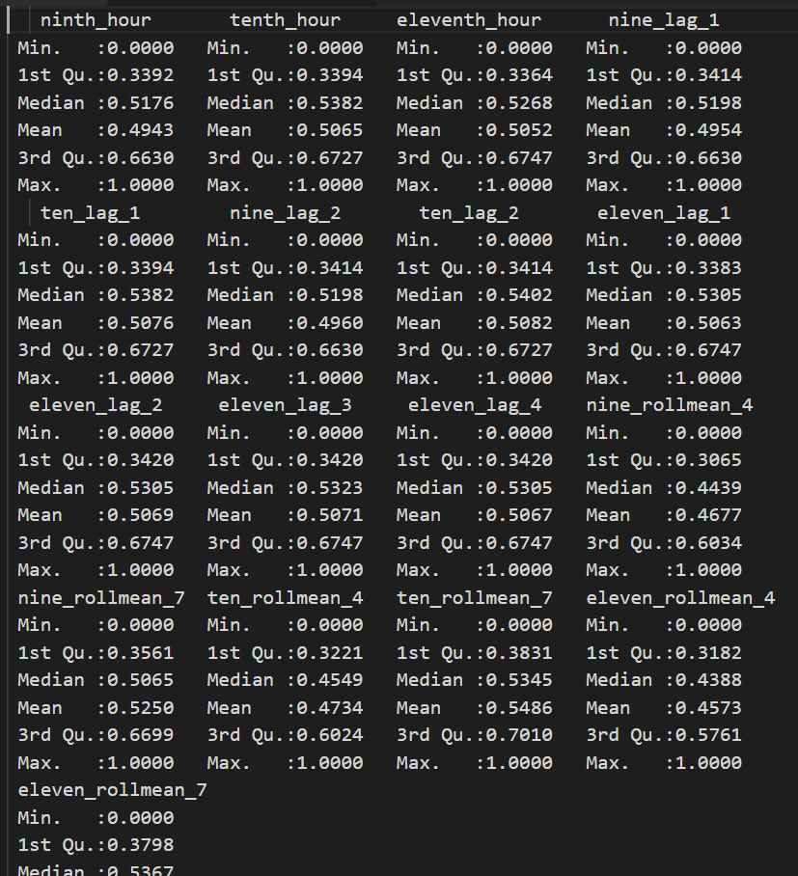

All the values scaled into 1 and 0 range.

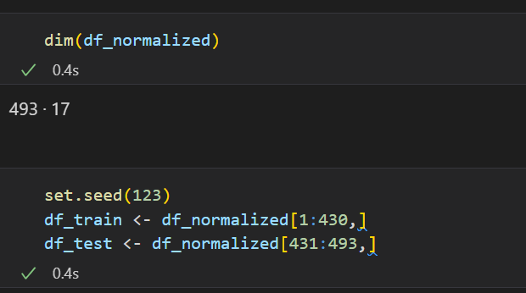

Above figure shows splitting dataset into training and testing data.

Function to experiment one hidden layer Neural Network Architecture.

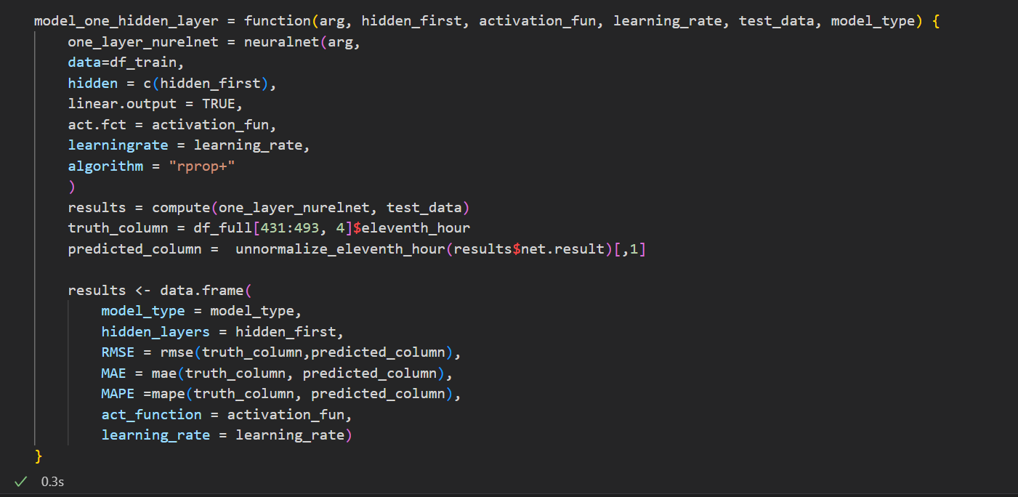

Function to experiment two hidden layer Neural Network Architecture.

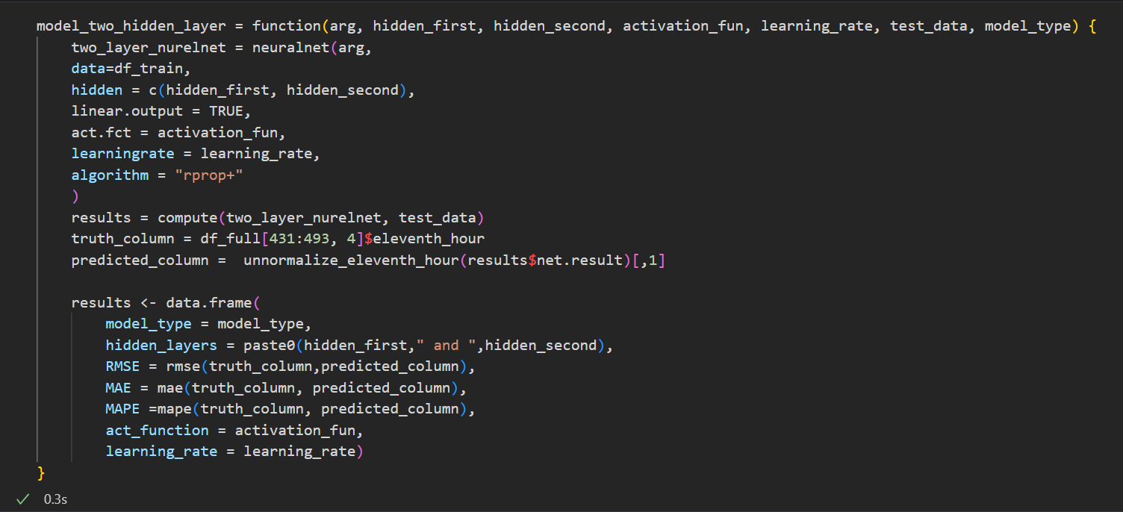

By using above functions, we will be able to experiment with input vectors, hidden layer nodes, activation function and learning rate in each model architecture.

**Standard Statistical Indices**

RMSE – Root Mean Squared Error

Standard deviation of the residuals (Predictions, Errors)

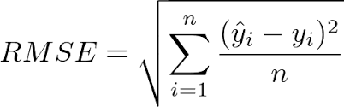

MAE – Mean Absolute Error

Measures average magnitude of the errors in a set of forecasts.

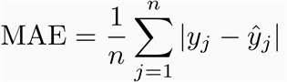

MAPE – Mean Absolute Percentage Error

Measures how accurate a forecast system is.

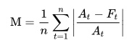

## One-hidden Layer Neural Network Architecture

In this step we will experiment single layer model architecture with different input vectors and different nodes and select the best single layer model with minimum error.

First Input set and results

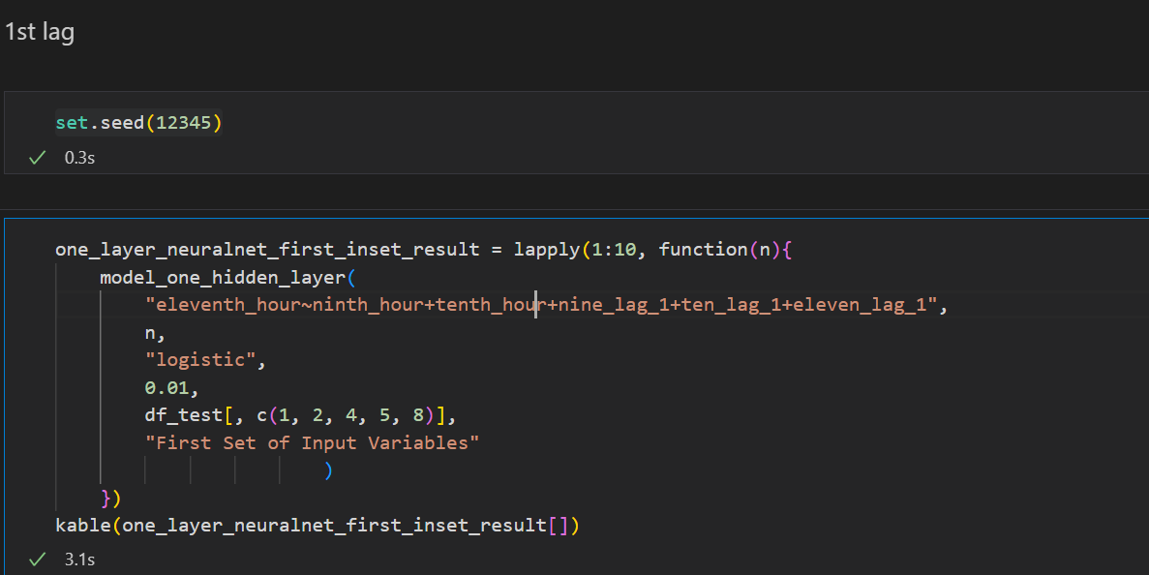

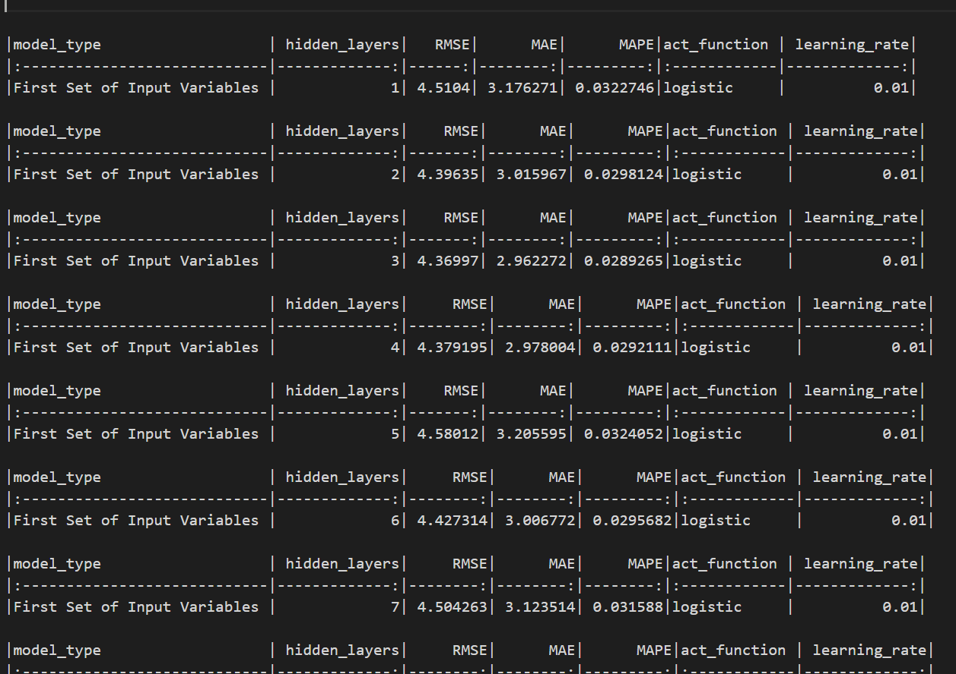

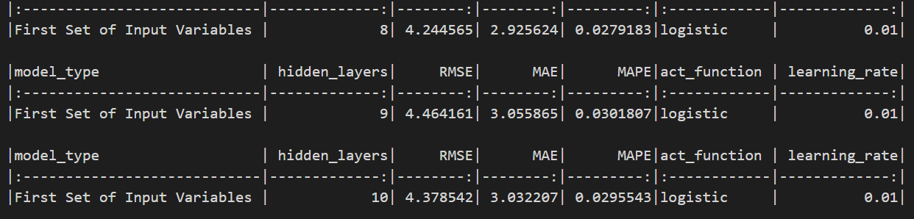

Second Input set and results

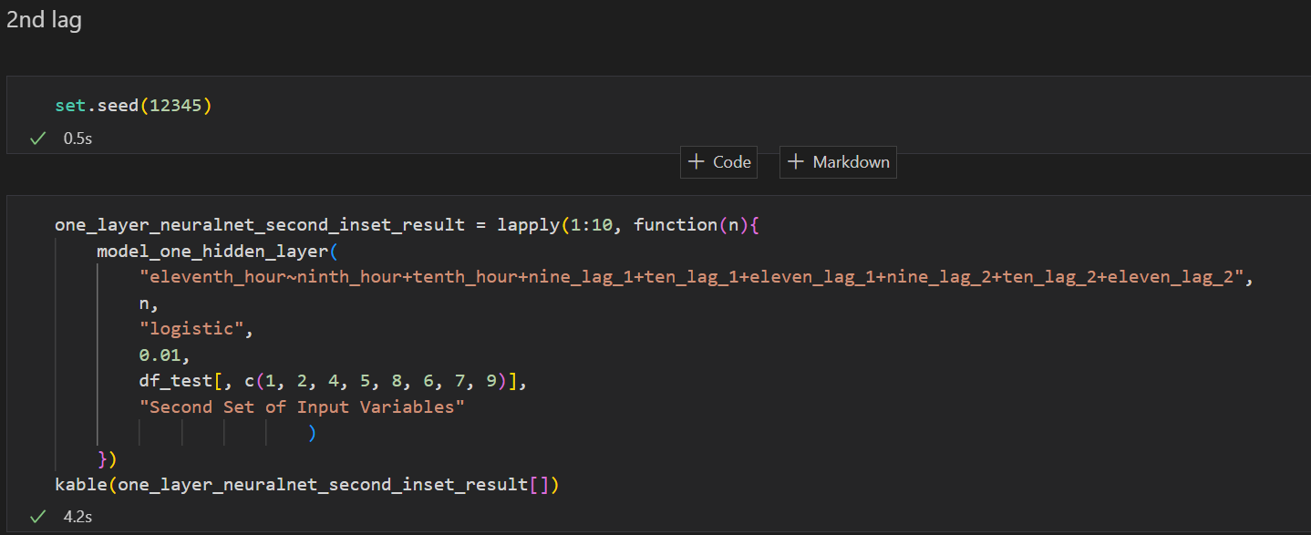

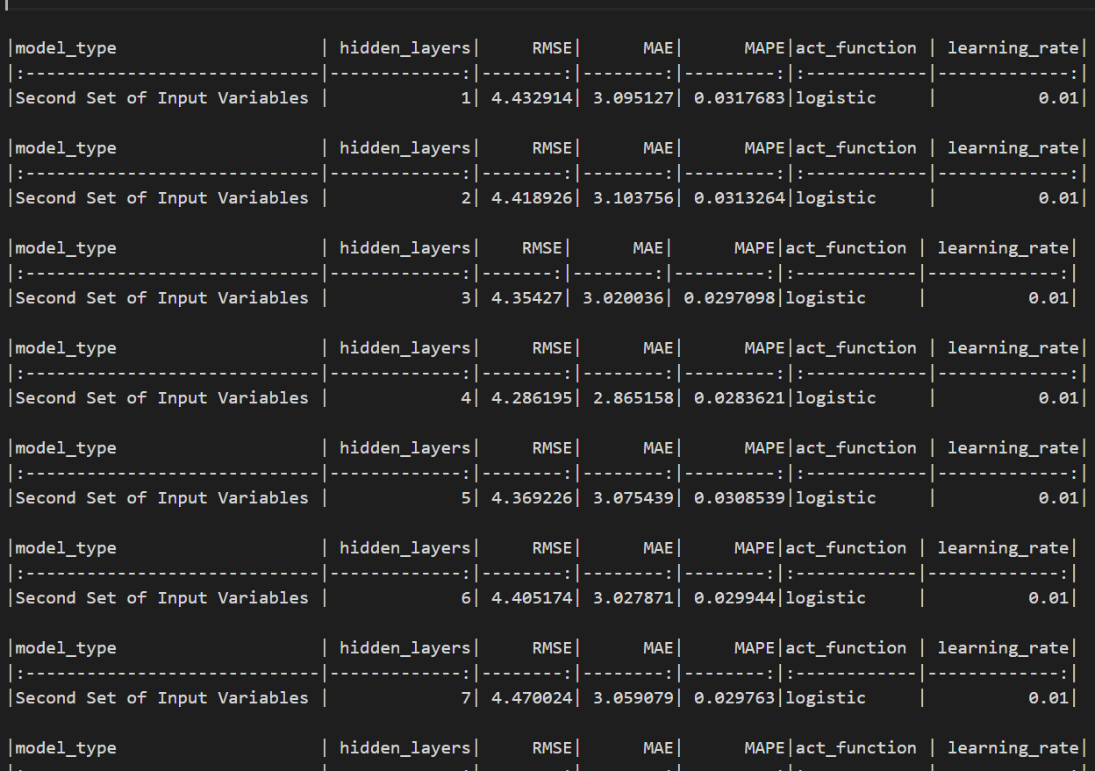

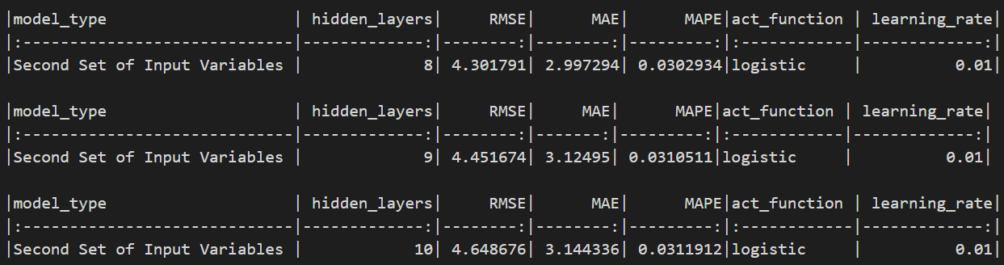

Third input set and results

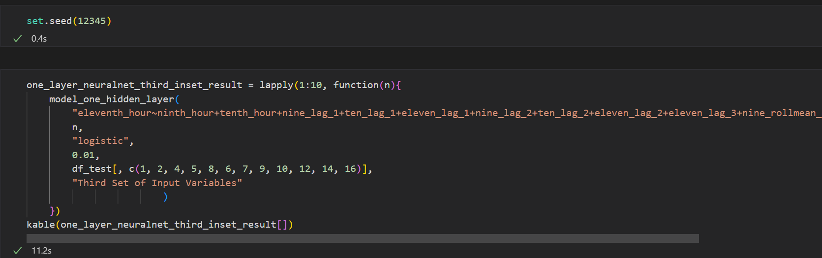

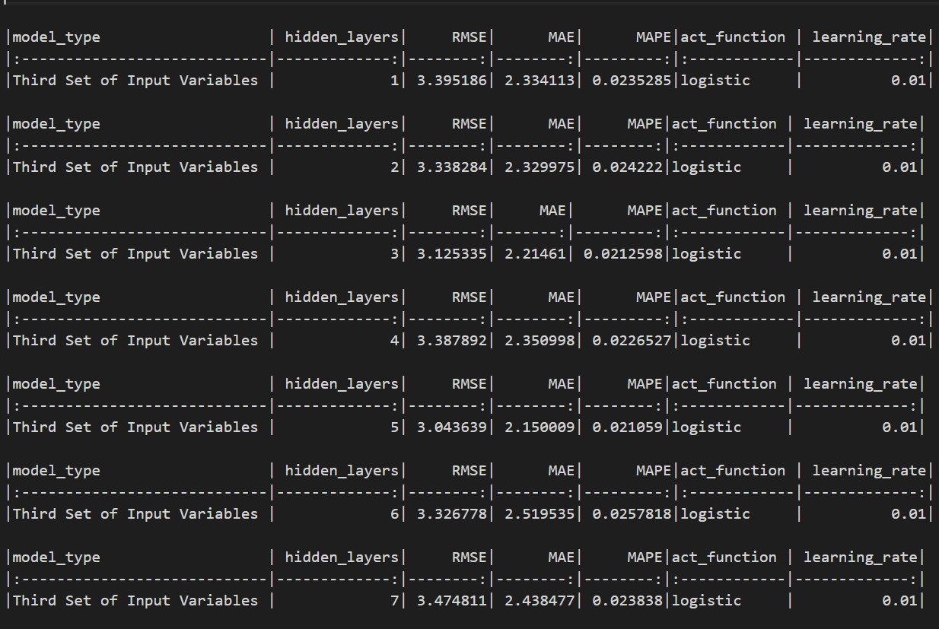

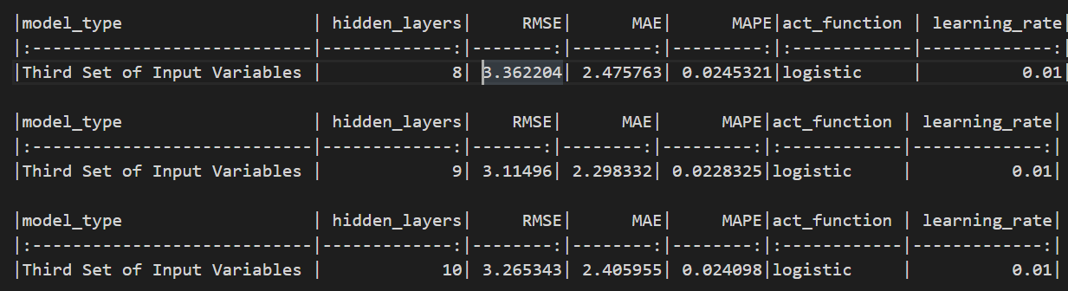

Forth input set and results

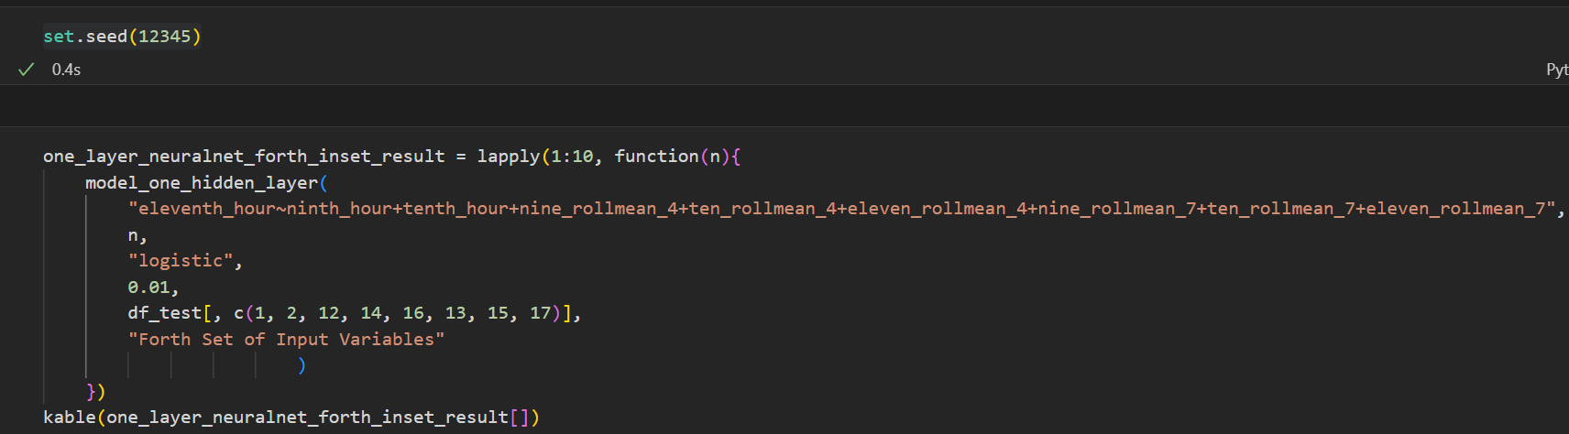

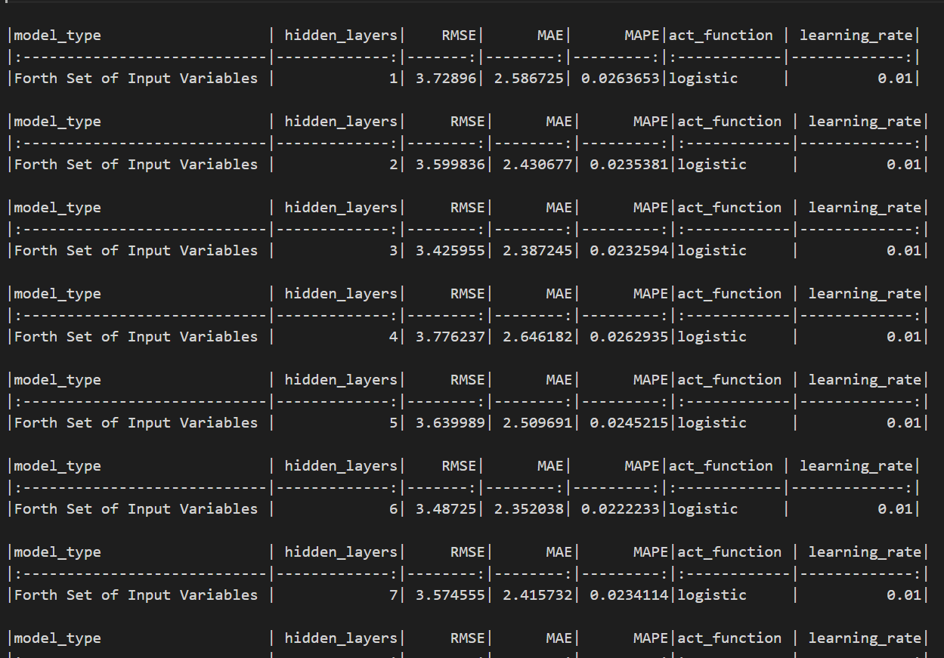

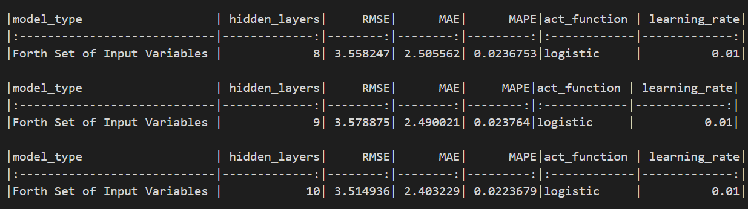

Models with minimum error in each input set

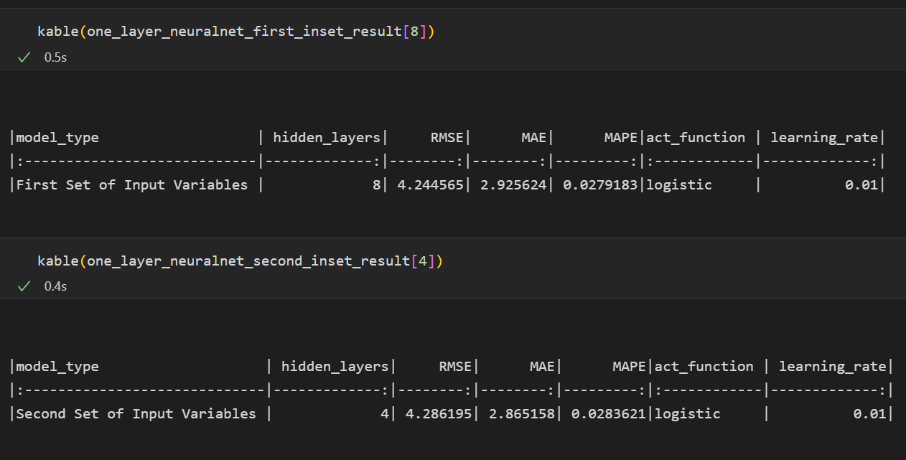

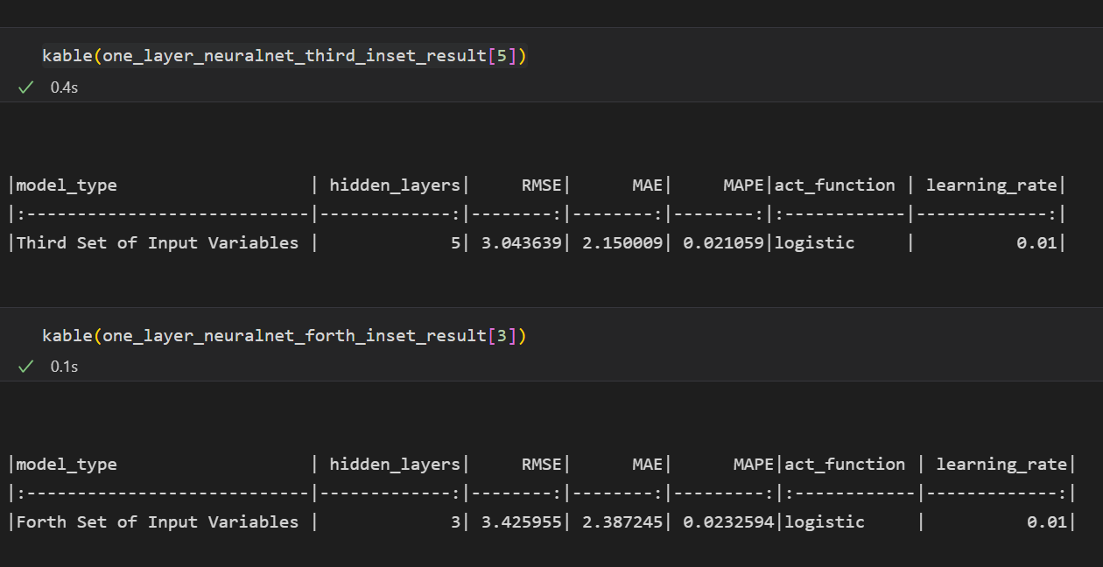

Among above network architectures network with 5 nodes in hidden layer and Third input set shows the minimum error, below figure shows stats of that model

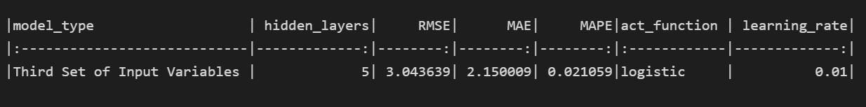

## Two-hidden Layer Neural Network Architecture

In this chapter we will experiment with two-hidden layer neural network architecture with different input sets and different node counts and select the best two-layer model with minimum error.

First input set and results

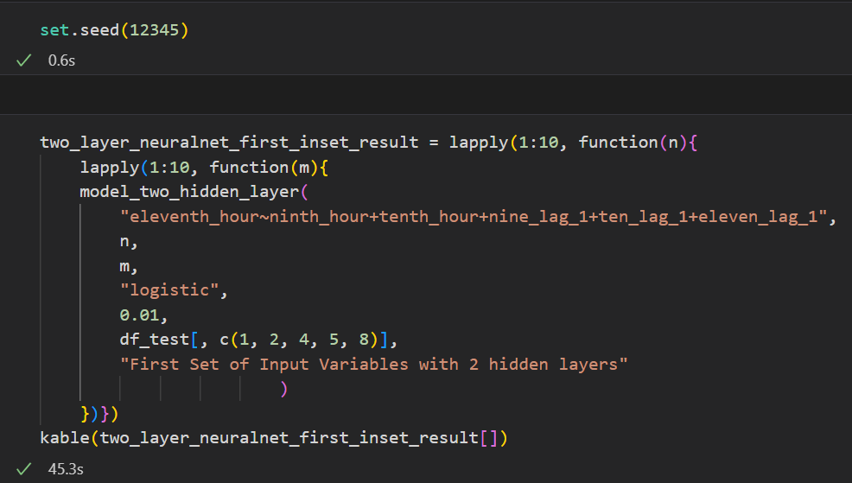

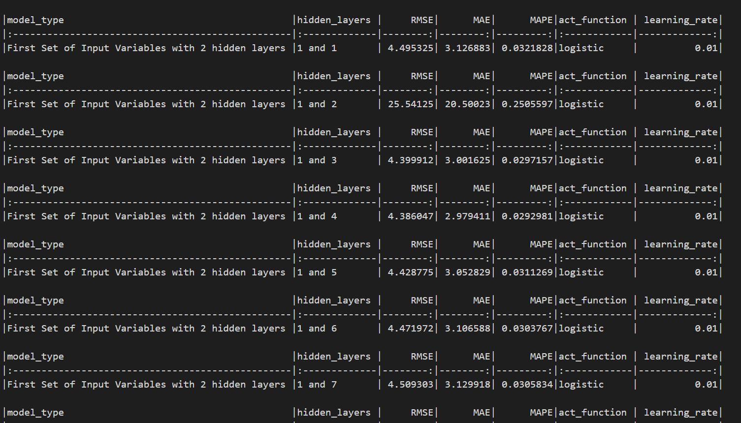

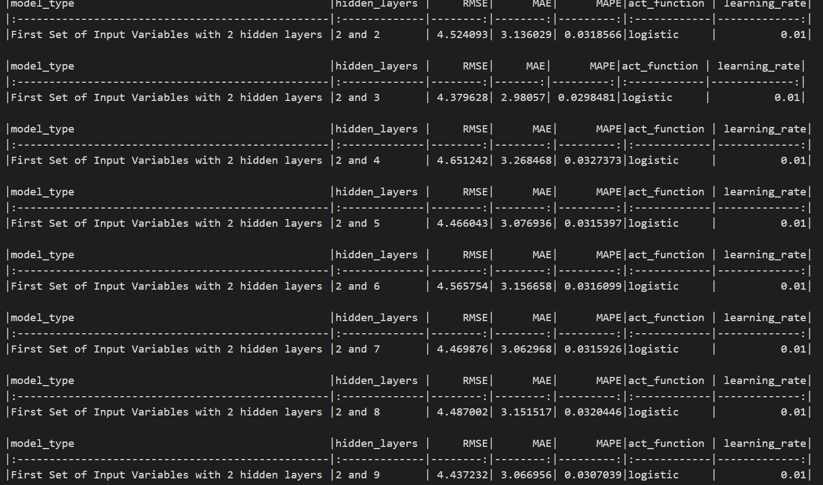

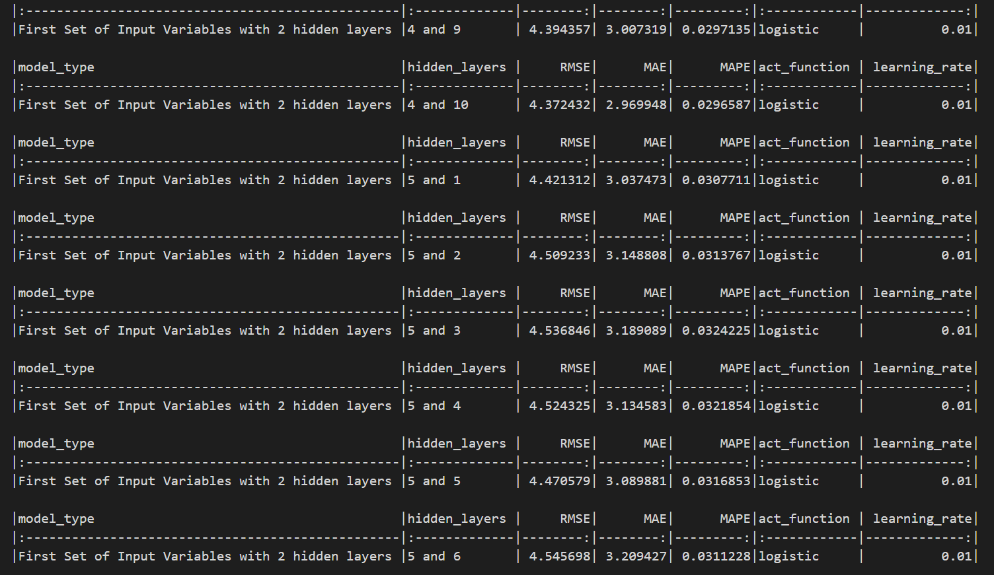

Second input set and results

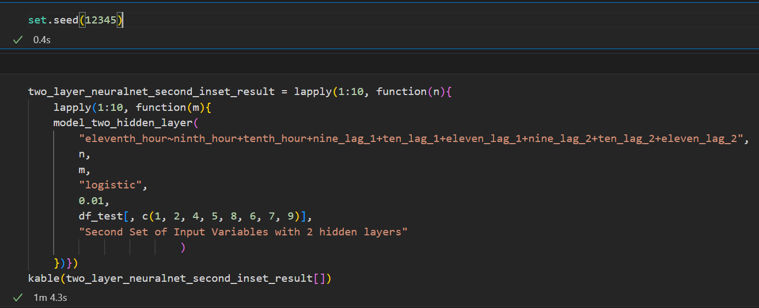

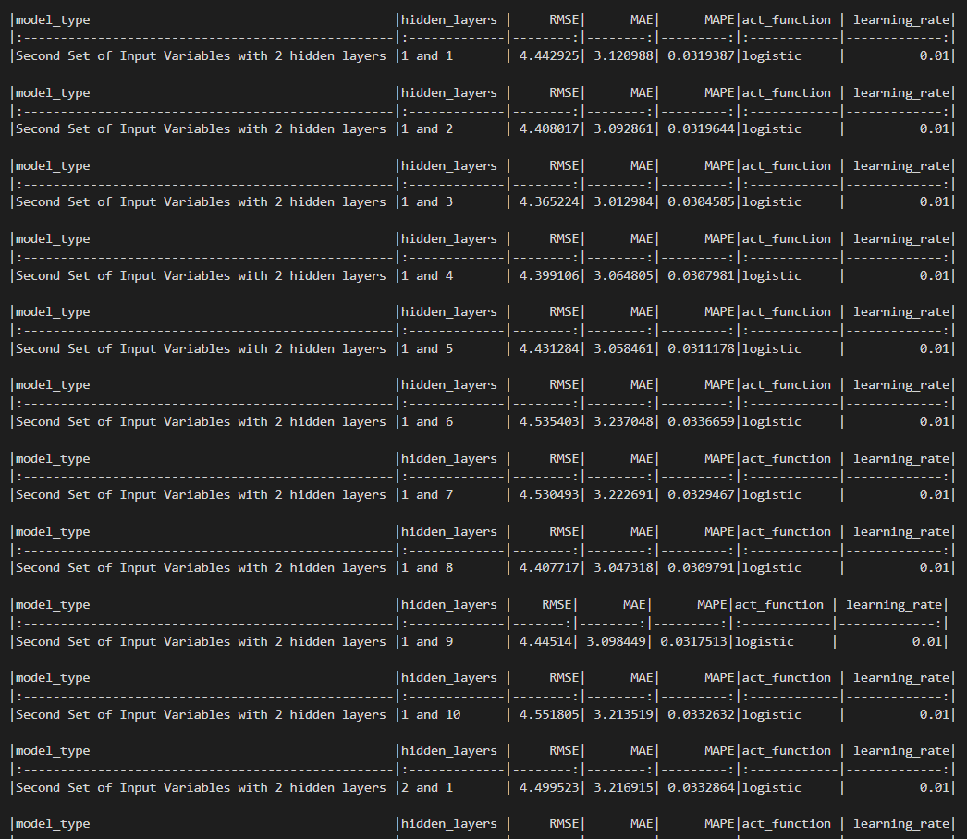

Third input set and results

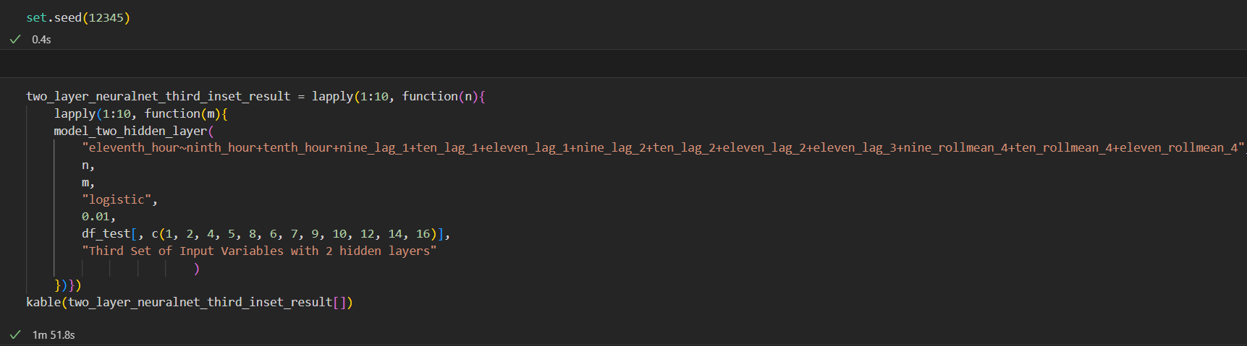

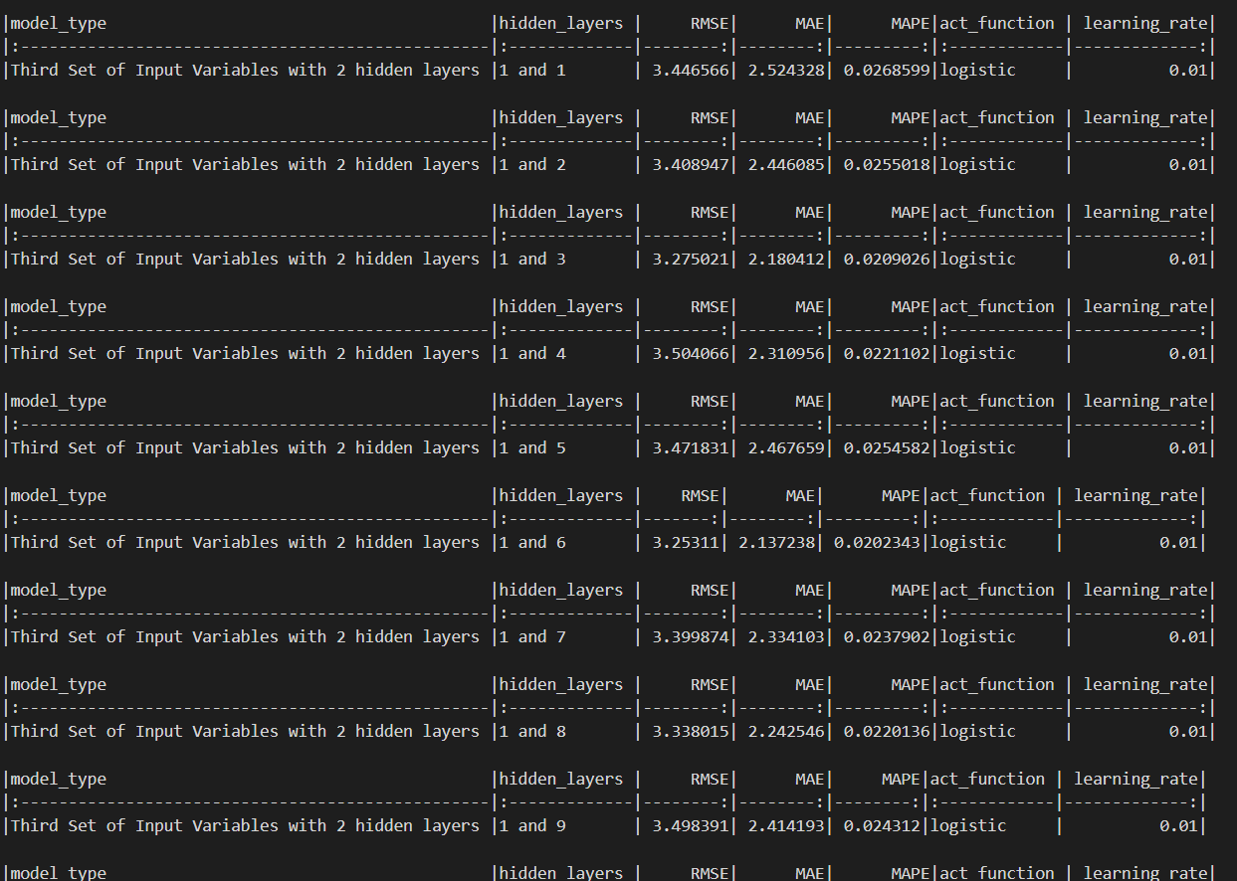

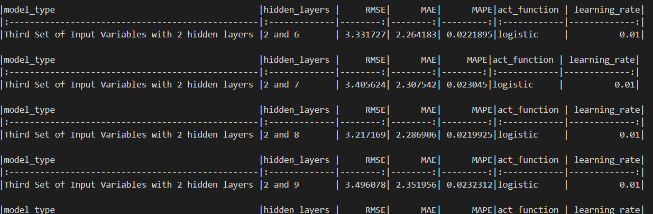

Forth input set and results

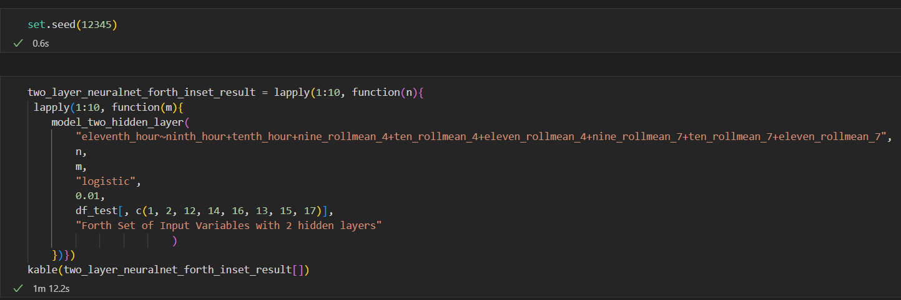

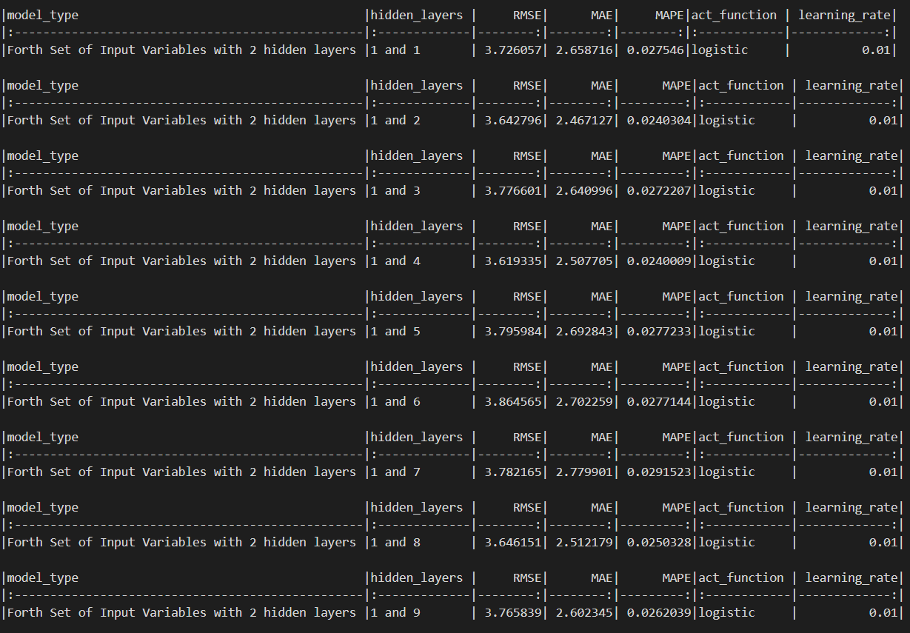

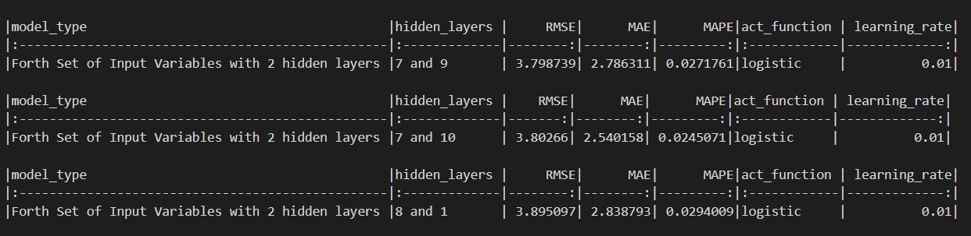

Models with minimum error in each input set









From above network architectures neural network with 10 and 3 in each hidden layer and third input set gave the minimum error and selected as the best architecture in two-hidden layer models.



**Best Models in one-hidden layer and two-hidden layer architecture**

One-hidden layer: Third input set and 5 nodes

Two-hidden layer: Third input set and 10 and 3 nodes in each hidden layer

## Experimenting with Learning rate

In Machine learning learning rate is tuning parameter in an optimization algorithm that helps to minimize the loss in loss function.

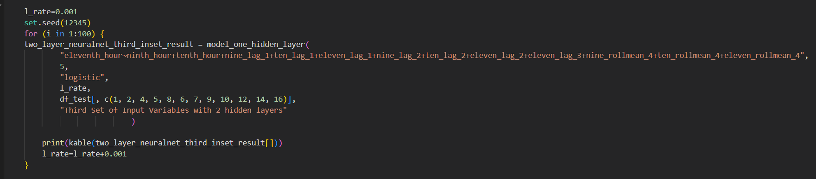

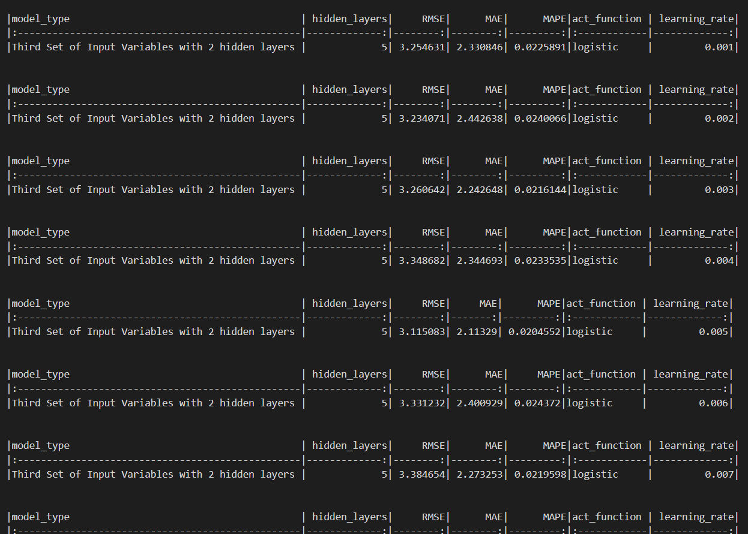

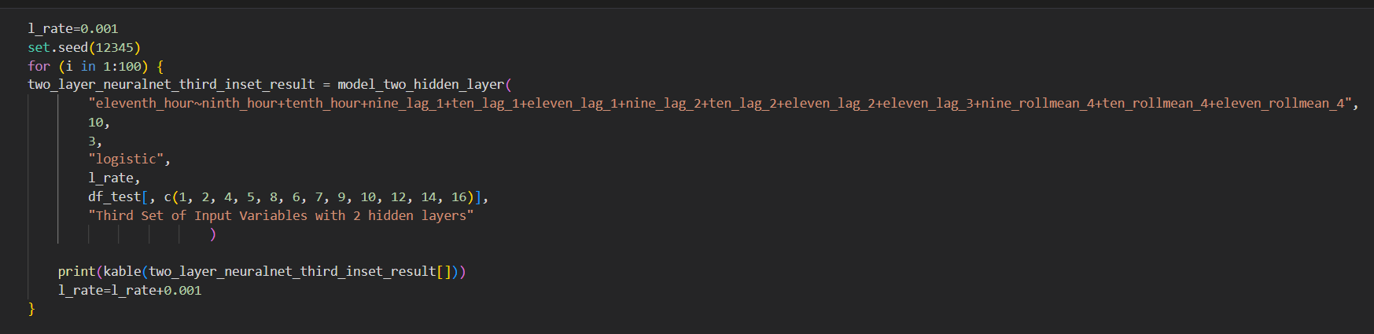

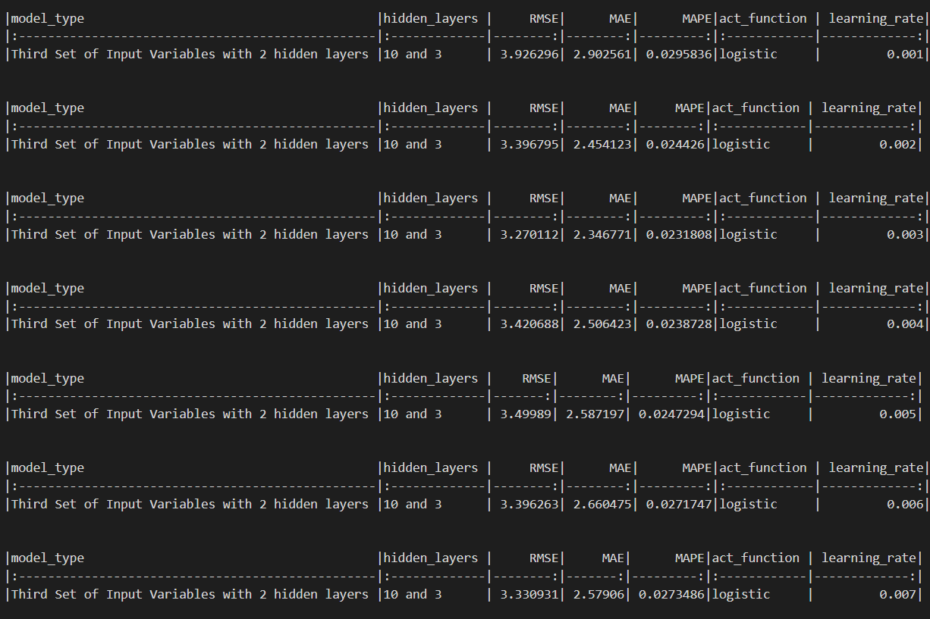

From above one-hidden layer and two-hidden layer approach minimum error given by two-hidden layer network architecture with learning rate = 0.037 and one-hidden layer minimum learning rate = 0.087 with comparing with these both models best model was two-hidden layer architecture which gave high performance with evaluation statistical indices (RMSE, MAE, MAPE)

## Prediction with best MLP architecture

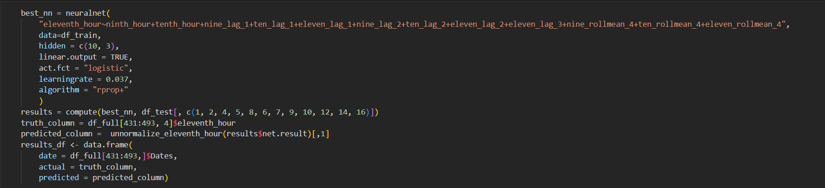

Above figure shows best network construction code and predictions using test dataset.

Plot MLP

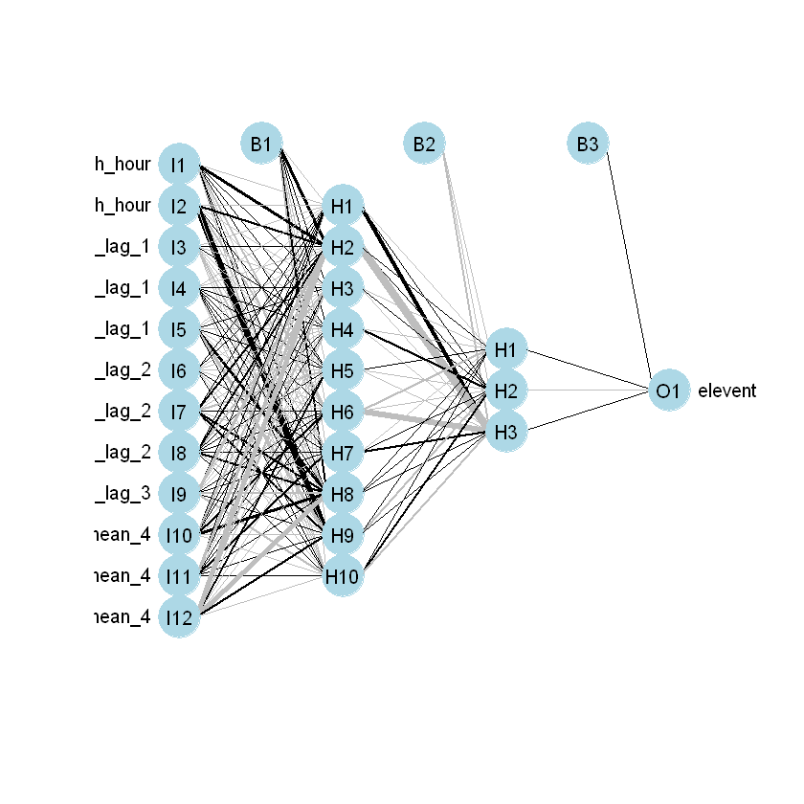

Predicted vs actual from best MLP

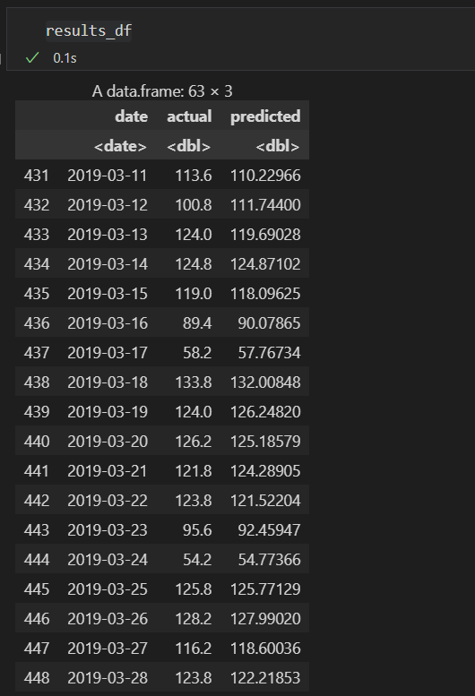

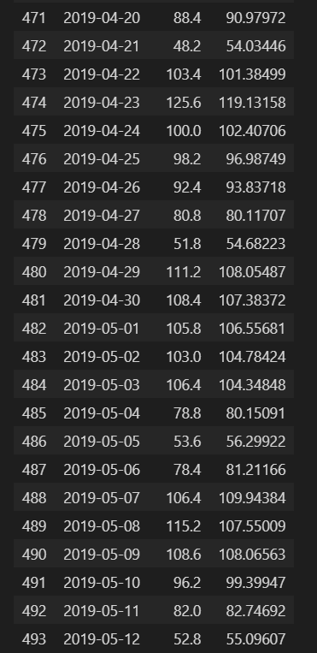

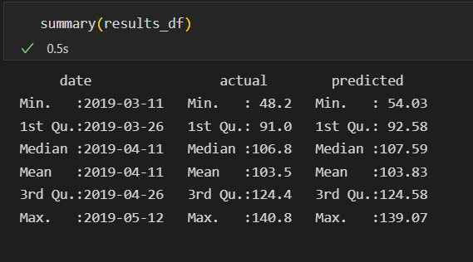

Plotting predicted vs actual result data frame

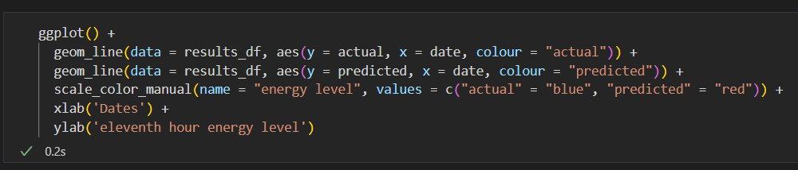

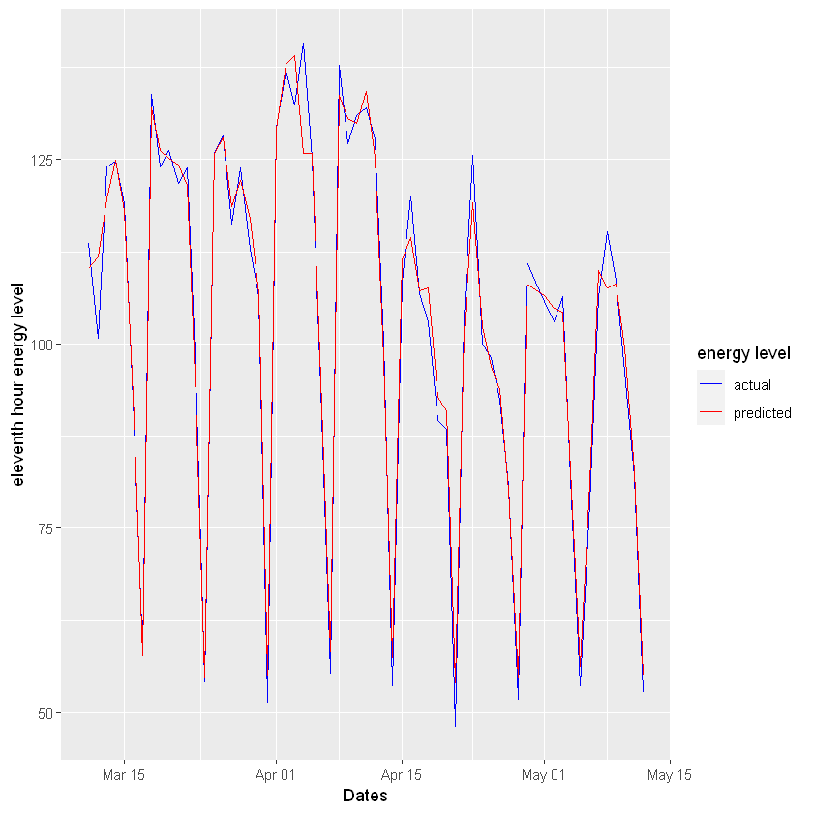

We can do some more optimizations to increase model forecasting accuracy.

# Appendix

## Clustering

# libraries

library("readxl")

options(warn = 0)

library(dplyr)

library(ggplot2)

library(caTools)

library(caret)

library(GGally)

library(janitor)

library(corrplot)

library(tidyverse)

library(hrbrthemes)

library(viridis)

library(NbClust)

library(factoextra)

library(gridExtra)

df <- read_excel("data/Whitewine_v2.xlsx")

#add index column to data frame

df$index <- 1:nrow(df)

head(df)

# replacing each quality measures into 1-4 range

# 1 wrost and 4 is best

df["quality"][df["quality"] == 5] <- 1

df["quality"][df["quality"] == 6] <- 2

df["quality"][df["quality"] == 7] <- 3

df["quality"][df["quality"] == 8] <- 4

head(df)

boxplot(df[1:11])

# format columns

df <- janitor::clean_names(df)

#EDA

summary(df)

#check null values

sum(is.na(df))

#Correlation Heatmap of Variables

corrplot(cor(df[1:12]))

z_score = function(x) {

  return((x - mean(x)) / sd(x))

}

dfNorm <- as.data.frame(lapply(df[1:11], z_score))

dfNorm$index <- 1:nrow(dfNorm)

head(dfNorm)

summary(dfNorm[1:11])

#only keep rows in dataframe with all z-scores less than absolute value of 3

no_outliers <- dfNorm[!rowSums(dfNorm[1:11]>3),]

head(no_outliers)

# merge normalized one ane orginal quality

# merge two data frames by ID

df_final <- merge(no_outliers,df[12:13],by="index")

head(df_final)

summary(df_final[2:12])

histogram = function(x,title,x_label) {

  # Add a Normal Curve (Thanks to Peter Dalgaard)

  x <- x

  h<-hist(x, breaks=10, col="red", xlab=x_label,

    main=title)

  xfit<-seq(min(x),max(x),length=40)

  yfit<-dnorm(xfit,mean=mean(x),sd=sd(x))

  yfit <- yfit*diff(h$mids[1:2])*length(x)

  lines(xfit, yfit, col="blue", lwd=2)

}

# histogram(df$fixed_acidity,"fixed_acidity values before preprocessing","fixed_acidity value")

# histogram(df_final$fixed_acidity,"fixed_acidity values after preprocessing","fixed_acidity value")

histogram(df$quality,"quality values before preprocessing","fixed_acidity value")

histogram(df_final$quality,"quality values after preprocessing","fixed_acidity value")

head(df_final)

# see the datasrt types

str(df_final)

df_nb <- df_final[2:12]

#setting seed point

set.seed(26)

# #euclidient distance

no_of_clusters_eud = NbClust(df_nb,distance="euclidean", min.nc=2,max.nc=10,method="kmeans",index="all")

# #manhatten

no_of_clusters_man = NbClust(df_nb,distance="manhattan", min.nc=2,max.nc=15,method="kmeans",index="all")

# #maximum

no_of_clusters_maximum = NbClust(df_nb,distance="maximum", min.nc=2,max.nc=15,method="kmeans",index="all")

fviz_nbclust(df_final[2:12],kmeans,method="wss")+geom_vline(xintercept=4,linetype=1)

k = 1:10

set.seed(25)

WSS = sapply(k, function(k) {kmeans(df_final[2:12], centers=k)$tot.withinss})

# You can then use a line plot to plot the within sum of squares with a different number of k

plot(k, WSS, type="b", xlab= "Number of k", ylab="Within sum of squares")

# silhouette

fviz_nbclust(df_final[2:12], kmeans, method = "silhouette") + labs(subtitle = "Silhoutte Method")

# clustering

head(df_final)

x=df_final[2:12]

y=df_final$quality

kc_2 <- kmeans(x,centers=2)

kc_2

str(kc_2)

table(y,kc_2$cluster)

# implement the metrix

confusionMatrix(

 factor(kc_2$cluster, levels = 1:4),

 factor(df_final$quality,levels=1:4)

)

fviz_cluster(kc_2,data=x)

kc_3 <- kmeans(x,centers=3)

kc_3

str(kc_3)

table(y,kc_3$cluster)

# implement the metrix

confusionMatrix(

 factor(kc_3$cluster, levels = 1:4),

 factor(df_final$quality,levels=1:4)

)

fviz_cluster(kc_3,data=x)

kc_4 <- kmeans(x,centers=4)

kc_4

str(kc_4)

table(y,kc_4$cluster)

# implement the metrix

confusionMatrix(

 factor(kc_4$cluster, levels = 1:4),

 factor(df_final$quality,levels=1:4)

)

fviz_cluster(kc_4,data=x)

# plots to compare

p1 <- fviz_cluster(kc_2, geom = "point", data = x) + ggtitle("k = 2")

p2 <- fviz_cluster(kc_3, geom = "point",  data = x) + ggtitle("k = 3")

p3 <- fviz_cluster(kc_4, geom = "point",  data = x) + ggtitle("k = 4")

grid.arrange(p1, p2, p3,nrow = 2)

head(df_final)

principle_components <- prcomp(df_final[2:12])

principle_components

summary(principle_components)

plot(principle_components)

plot(principle_components, type = "l")

biplot(principle_components)

biplot(principle_components, scale = 0)

str(principle_components)

df_final_with_pcs <- cbind(df_final, principle_components$x)

head(df_final_with_pcs)

library(ggplot2)

ggplot(df_final_with_pcs, aes(PC9,PC10,PC11,col = quality, fill = quality)) +

  stat_ellipse(geom = "polygon", col = "black", alpha = 0.5) +

  geom_point(shape = 21, col = "black")

x_2 = df_final_with_pcs[22:24]

y_2 = df_final_with_pcs$quality

kcpca <- kmeans(x_2,4)

kcpca

fviz_cluster(kcpca,data=x_2)

table(y_2,kcpca$cluster)

## Forecasting

# libraries

library(readxl)

options(warn = 0)

library(tidyverse)

library(readxl)

library(lubridate)

library(zoo)

library(readxl)

library(neuralnet)

library(knitr)

library(Metrics)

library(NeuralNetTools)

df <- read_excel("data/UOW_load.xlsx")

head(df)

df$Dates<-as.Date(df$Dates)

names(df)[2] <- paste("ninth_hour")

names(df)[3] <- paste("tenth_hour")

names(df)[4] <- paste("eleventh_hour")

head(df)

summary(df[2:4])

# insert all the inputs to the one data frame

# creating revious time frame values for autoregressive model

df_full = df %>%

 mutate(

    nine_lag_1 = lag(df$ninth_hour,1),

    ten_lag_1 = lag(df$tenth_hour,1),

    nine_lag_2 = lag(df$ninth_hour,2),

    ten_lag_2 = lag(df$tenth_hour,2),

    eleven_lag_1 = lag(df$eleventh_hour,1),

    eleven_lag_2 = lag(df$eleventh_hour,2),

    eleven_lag_3 = lag(df$eleventh_hour,3),

    eleven_lag_4 = lag(df$eleventh_hour,4),

    #roll mean

    nine_rollmean_4 = rollmean(ninth_hour,4, fill = NA),

    nine_rollmean_7 = rollmean(ninth_hour,7, fill = NA),

    ten_rollmean_4 = rollmean(tenth_hour,4, fill = NA),

    ten_rollmean_7 = rollmean(tenth_hour,7, fill = NA),

    eleven_rollmean_4 = rollmean(eleventh_hour,4, fill = NA),

    eleven_rollmean_7 = rollmean(eleventh_hour,7, fill = NA)) %>%

#Drop null coulumns

drop_na()

head(df_full)

#1st lag

df_full %>%

pivot_longer(cols = c(2, 3, 5, 6, 9), names_to = "kind", values_to = "energy_level") %>%

ggplot(aes(Dates, energy_level, color = kind)) +

geom_line() +

facet_wrap(~kind) + theme(axis.text.x = element_text(angle = 45, vjust =

0.5, hjust = 1

)) +

labs(x = "",

title = "First Set of Input Variables") +

theme(legend.position = "none")

#2nd lag

df_full %>%

pivot_longer(cols = c(2, 3, 5, 6, 9, 7, 8, 10), names_to = "kind", values_to = "energy_level") %>%

ggplot(aes(Dates, energy_level, color = kind)) +

geom_line() +

facet_wrap(~kind) + theme(axis.text.x = element_text(angle = 45, vjust =

0.5, hjust = 1

)) +

labs(x = "",

title = "Second Set of Input Variables") +

theme(legend.position = "none")

#3rd lag

df_full %>%

pivot_longer(cols = c(2, 3, 5, 6, 9, 7, 8, 10, 11, 13, 15, 17), names_to = "kind", values_to = "energy_level") %>%

ggplot(aes(Dates, energy_level, color = kind)) +

geom_line() +

facet_wrap(~kind) + theme(axis.text.x = element_text(angle = 45, vjust =

0.5, hjust = 1

)) +

labs(x = "",

title = "Third Set of Input Variables") +

theme(legend.position = "none")

#4thd lag

df_full %>%

pivot_longer(cols = c(13, 14, 15, 16, 17, 18), names_to = "kind", values_to = "energy_level") %>%

ggplot(aes(Dates, energy_level, color = kind)) +

geom_line() +

facet_wrap(~kind) + theme(axis.text.x = element_text(angle = 45, vjust =

0.5, hjust = 1

)) +

labs(x = "",

title = "Forth Set of Input Variables") +

theme(legend.position = "none")

#normalization

head(df_full)

summary(df_full)

# min max normalize

min_max_normalize <- function(x) {

return ((x - min(x)) / (max(x) - min(x))) }

unnormalize_eleventh_hour <- function(x) {

return( (max(df_full$eleventh_hour) - min(df_full$eleventh_hour))*x + min(df_full$eleventh_hour)) }

df_normalized <- as.data.frame(lapply(df_full[2:18], min_max_normalize))

head(df_normalized)

summary(df_normalized)

dim(df_normalized)

# train test split

set.seed(123)

df_train <- df_normalized[1:430,]

df_test <- df_normalized[431:493,]

# one-hidden layer function

model_one_hidden_layer = function(arg, hidden_first, activation_fun, learning_rate, test_data, model_type) {

    one_layer_nurelnet = neuralnet(arg,

    data=df_train,

    hidden = c(hidden_first),

    linear.output = TRUE,

    act.fct = activation_fun,

    learningrate = learning_rate,

    algorithm = "rprop+"

    )

    results = compute(one_layer_nurelnet, test_data)

    truth_column = df_full[431:493, 4]$eleventh_hour

    predicted_column =  unnormalize_eleventh_hour(results$net.result)[,1]

    results <- data.frame(

        model_type = model_type,

        hidden_layers = hidden_first,

        RMSE = rmse(truth_column,predicted_column),

        MAE = mae(truth_column, predicted_column),

        MAPE =mape(truth_column, predicted_column),

        act_function = activation_fun,

        learning_rate = learning_rate)

}

#two-hidden layer funcation

model_two_hidden_layer = function(arg, hidden_first, hidden_second, activation_fun, learning_rate, test_data, model_type) {

    two_layer_nurelnet = neuralnet(arg,

    data=df_train,

    hidden = c(hidden_first, hidden_second),

    linear.output = TRUE,

    act.fct = activation_fun,

    learningrate = learning_rate,

    algorithm = "rprop+"

    )

    results = compute(two_layer_nurelnet, test_data)

    truth_column = df_full[431:493, 4]$eleventh_hour

    predicted_column =  unnormalize_eleventh_hour(results$net.result)[,1]

    results <- data.frame(

        model_type = model_type,

        hidden_layers = paste0(hidden_first," and ",hidden_second),

        RMSE = rmse(truth_column,predicted_column),

        MAE = mae(truth_column, predicted_column),

        MAPE =mape(truth_column, predicted_column),

        act_function = activation_fun,

        learning_rate = learning_rate)

}

# one-hidden layer experiments

# firse input set

set.seed(12345)

one_layer_neuralnet_first_inset_result = lapply(1:10, function(n){

    model_one_hidden_layer(

        "eleventh_hour~ninth_hour+tenth_hour+nine_lag_1+ten_lag_1+eleven_lag_1",

        n,

        "logistic",

        0.01,

        df_test[, c(1, 2, 4, 5, 8)],

        "First Set of Input Variables"

                        )

    })

kable(one_layer_neuralnet_first_inset_result[])

# second input set

set.seed(12345)

one_layer_neuralnet_second_inset_result = lapply(1:10, function(n){

    model_one_hidden_layer(

        "eleventh_hour~ninth_hour+tenth_hour+nine_lag_1+ten_lag_1+eleven_lag_1+nine_lag_2+ten_lag_2+eleven_lag_2",

        n,

        "logistic",

        0.01,

        df_test[, c(1, 2, 4, 5, 8, 6, 7, 9)],

        "Second Set of Input Variables"

                        )

    })

kable(one_layer_neuralnet_second_inset_result[])

# third input set

set.seed(12345)

one_layer_neuralnet_third_inset_result = lapply(1:10, function(n){

    model_one_hidden_layer(

        "eleventh_hour~ninth_hour+tenth_hour+nine_lag_1+ten_lag_1+eleven_lag_1+nine_lag_2+ten_lag_2+eleven_lag_2+eleven_lag_3+nine_rollmean_4+ten_rollmean_4+eleven_rollmean_4",

        n,

        "logistic",

        0.01,

        df_test[, c(1, 2, 4, 5, 8, 6, 7, 9, 10, 12, 14, 16)],

        "Third Set of Input Variables"

                        )

    })

kable(one_layer_neuralnet_third_inset_result[])

# forth input set

set.seed(12345)

one_layer_neuralnet_forth_inset_result = lapply(1:10, function(n){

    model_one_hidden_layer(

        "eleventh_hour~ninth_hour+tenth_hour+nine_rollmean_4+ten_rollmean_4+eleven_rollmean_4+nine_rollmean_7+ten_rollmean_7+eleven_rollmean_7",

        n,

        "logistic",

        0.01,

        df_test[, c(1, 2, 12, 14, 16, 13, 15, 17)],

        "Forth Set of Input Variables"

                        )

    })

kable(one_layer_neuralnet_forth_inset_result[])

kable(one_layer_neuralnet_first_inset_result[8])

kable(one_layer_neuralnet_second_inset_result[4])

kable(one_layer_neuralnet_third_inset_result[5])

kable(one_layer_neuralnet_forth_inset_result[3])

# best one-hidden layer

kable(one_layer_neuralnet_third_inset_result[5])

# two-hidden layer experiments

# 1st input set

set.seed(12345)

two_layer_neuralnet_first_inset_result = lapply(1:10, function(n){

    lapply(1:10, function(m){

    model_two_hidden_layer(

        "eleventh_hour~ninth_hour+tenth_hour+nine_lag_1+ten_lag_1+eleven_lag_1",

        n,

        m,

        "logistic",

        0.01,

        df_test[, c(1, 2, 4, 5, 8)],

        "First Set of Input Variables with 2 hidden layers"

                        )

    })})

kable(two_layer_neuralnet_first_inset_result[])

# 2nd input set

set.seed(12345)

two_layer_neuralnet_second_inset_result = lapply(1:10, function(n){

    lapply(1:10, function(m){

    model_two_hidden_layer(

        "eleventh_hour~ninth_hour+tenth_hour+nine_lag_1+ten_lag_1+eleven_lag_1+nine_lag_2+ten_lag_2+eleven_lag_2",

        n,

        m,

        "logistic",

        0.01,

        df_test[, c(1, 2, 4, 5, 8, 6, 7, 9)],

        "Second Set of Input Variables with 2 hidden layers"

                        )

    })})

kable(two_layer_neuralnet_second_inset_result[])

# 3rd input set

set.seed(12345)

two_layer_neuralnet_third_inset_result = lapply(1:10, function(n){

    lapply(1:10, function(m){

    model_two_hidden_layer(

        "eleventh_hour~ninth_hour+tenth_hour+nine_lag_1+ten_lag_1+eleven_lag_1+nine_lag_2+ten_lag_2+eleven_lag_2+eleven_lag_3+nine_rollmean_4+ten_rollmean_4+eleven_rollmean_4",

        n,

        m,

        "logistic",

        0.01,

        df_test[, c(1, 2, 4, 5, 8, 6, 7, 9, 10, 12, 14, 16)],

        "Third Set of Input Variables with 2 hidden layers"

                        )

    })})

kable(two_layer_neuralnet_third_inset_result[])

# 4th input set

set.seed(12345)

two_layer_neuralnet_forth_inset_result = lapply(1:10, function(n){

 lapply(1:10, function(m){

    model_two_hidden_layer(

        "eleventh_hour~ninth_hour+tenth_hour+nine_rollmean_4+ten_rollmean_4+eleven_rollmean_4+nine_rollmean_7+ten_rollmean_7+eleven_rollmean_7",

        n,

        m,

        "logistic",

        0.01,

        df_test[, c(1, 2, 12, 14, 16, 13, 15, 17)],

        "Forth Set of Input Variables with 2 hidden layers"

                        )

    })})

kable(two_layer_neuralnet_forth_inset_result[])

kable(two_layer_neuralnet_first_inset_result[8])

# 8 and 2

kable(two_layer_neuralnet_second_inset_result[4])

# 4 and 6

kable(two_layer_neuralnet_third_inset_result[10])

# 10 and 3

kable(two_layer_neuralnet_forth_inset_result[3])

# 3 and 7

# learning rate experiments

l_rate=0.001

set.seed(12345)

for (i in 1:100) {

two_layer_neuralnet_third_inset_result = model_two_hidden_layer(

        "eleventh_hour~ninth_hour+tenth_hour+nine_lag_1+ten_lag_1+eleven_lag_1+nine_lag_2+ten_lag_2+eleven_lag_2+eleven_lag_3+nine_rollmean_4+ten_rollmean_4+eleven_rollmean_4",

        10,

        3,

        "logistic",

        l_rate,

        df_test[, c(1, 2, 4, 5, 8, 6, 7, 9, 10, 12, 14, 16)],

        "Third Set of Input Variables with 2 hidden layers"

                        )

    print(kable(two_layer_neuralnet_third_inset_result[]))

    l_rate=l_rate+0.001

}

l_rate=0.001

set.seed(12345)

for (i in 1:100) {

two_layer_neuralnet_third_inset_result = model_one_hidden_layer(

        "eleventh_hour~ninth_hour+tenth_hour+nine_lag_1+ten_lag_1+eleven_lag_1+nine_lag_2+ten_lag_2+eleven_lag_2+eleven_lag_3+nine_rollmean_4+ten_rollmean_4+eleven_rollmean_4",

        5,

        "logistic",

        l_rate,

        df_test[, c(1, 2, 4, 5, 8, 6, 7, 9, 10, 12, 14, 16)],

        "Third Set of Input Variables with 2 hidden layers"

                        )

    print(kable(two_layer_neuralnet_third_inset_result[]))

    l_rate=l_rate+0.001

}

# final two-hidden layer

final_two_layer = model_two_hidden_layer(

        "eleventh_hour~ninth_hour+tenth_hour+nine_lag_1+ten_lag_1+eleven_lag_1+nine_lag_2+ten_lag_2+eleven_lag_2+eleven_lag_3+nine_rollmean_4+ten_rollmean_4+eleven_rollmean_4",

        10,

        3,

        "logistic",

        0.037,

        df_test[, c(1, 2, 4, 5, 8, 6, 7, 9, 10, 12, 14, 16)],

        "Third Set of Input Variables with 2 hidden layers"

                        )

    print(kable(final_two_layer[]))

# final one-hidden layer

final_single_layer = model_one_hidden_layer(

        "eleventh_hour~ninth_hour+tenth_hour+nine_lag_1+ten_lag_1+eleven_lag_1+nine_lag_2+ten_lag_2+eleven_lag_2+eleven_lag_3+nine_rollmean_4+ten_rollmean_4+eleven_rollmean_4",

        5,

        "logistic",

        0.087,

        df_test[, c(1, 2, 4, 5, 8, 6, 7, 9, 10, 12, 14, 16)],

        "Third Set of Input Variables with 2 hidden layers"

                        )

    print(kable(final_single_layer[]))

# construct best network and predict

best_nn = neuralnet(

    "eleventh_hour~ninth_hour+tenth_hour+nine_lag_1+ten_lag_1+eleven_lag_1+nine_lag_2+ten_lag_2+eleven_lag_2+eleven_lag_3+nine_rollmean_4+ten_rollmean_4+eleven_rollmean_4",

    data=df_train,

    hidden = c(10, 3),

    linear.output = TRUE,

    act.fct = "logistic",

    learningrate = 0.037,

    algorithm = "rprop+"

    )

results = compute(best_nn, df_test[, c(1, 2, 4, 5, 8, 6, 7, 9, 10, 12, 14, 16)])

truth_column = df_full[431:493, 4]$eleventh_hour

predicted_column =  unnormalize_eleventh_hour(results$net.result)[,1]

results_df <- data.frame(

    date = df_full[431:493,]$Dates,

    actual = truth_column,

    predicted = predicted_column)

plotnet(best_nn)

rmse(truth_column,predicted_column)

results_df

summary(results_df)

# plot actual vs predicted

ggplot() +

  geom_line(data = results_df, aes(y = actual, x = date, colour = "actual")) +

  geom_line(data = results_df, aes(y = predicted, x = date, colour = "predicted")) +

  scale_color_manual(name = "energy level", values = c("actual" = "blue", "predicted" = "red")) +

  xlab('Dates') +

  ylab('eleventh hour energy level')

# References

Basaran, U. and Kurban, M., 2007. A New Approach for the Short-Term Load Forecasting with Autoregressive and Artificial Neural Network Models. *International Journal of Computational Intelligence Research*, 3(1).

Datacamp. 2022. *Neural Network Models in R*. [online] Available at: <https://www.datacamp.com/tutorial/neural-network-models-r> [Accessed 9 May 2022].

Uc-r.github.io. 2022. *K-means Cluster Analysis · UC Business Analytics R Programming Guide*. [online] Available at: <https://uc-r.github.io/kmeans_clustering> [Accessed 9 May 2022].